Table of Contents

Page No.

Chapter 1. Introduction
- Introduction to the System 4
- Problem Definition 4
- Aim 4
- Objective 4
- Goal 5
- Need of System 5

Chapter 2. Hardware and Software requirement
- Introduction 7
- System environment 7
- Software requirement 8
- Hardware requirements 8

Chapter 3. System Analysis
- Purpose 9
- Project Scope 9
- Existing System 9
- Proposed System 9
- System Description 10

Chapter 4.Implementation issues

- PHP 11
- AJAX 13
- Cascading style sheet(CSS) 16
System Description
Chapter 5. System Design
- Introduction 21
- Conceptual Design 22
- ER-Diagram 23
- Logical Design 23
- Physical Design 24
- Data Flow Diagram of “Online Airline Reservation System”
24

Chapter 6.User Screens 25-32

Chapter 7.Coding 33-113

Chapter 8. Conclusion
- Features of “Online Airline Reservation System” 114
- Benefits Accrued from “Online Airline Reservation System”114
- Limitations of “Online Airline Reservation System” 115

Bibliography

CHAPTER # 1

Introduction
Contents:
- Introduction
- Problem Definition
- Aim
- Objective
- Goal
- Need of System

Introduction to the System:
The main aim of the project was to develop a website which would facilitate the reservation of online air tickets through an effective and yet simple GUI for a normal passenger intending to travel in airways. Apart from reserving tickets, through our system a passenger can compare online fares ‘from’ various cities ‘to’ various cities.

Problem Definition:
Managing your Online Airline Reservation System may seem tricky, but a ARS is part of Passenger Service System (application support direct contact with passenger)
.

Aim:

“To Manage Online Airline Reservation System”.

Objective:
- To perform a thorough analysis of working of the whole System.
- To study the problems in the System through fact finding techniques.
- To follow SDLC to develop the system.
- To develop conceptual, logical and physical model for the system.
- To develop Graphical User Interface (GUI) as per convenience of the user.
- To implement the physical model, being tested as per the standards.
- To document our efforts and analysis in a proper comprehensible manner.

Goal:
∙ The project is basically targeted at those people who would like to travel through air and have an Internet access.
- Finally passengers curious in comparing the prices for various Airlines for their selected source and destination cities form our third category of audience
- To make a database that is consistent, reliable and secure.
- To provide correct, complete, ongoing information.
- To develop a well-organized information storage system.
- To make good documentation so as to facilitate possible future enhancements.

Need of the System:
There is always a need of a system that will perform to register by online .The Airline Tickets can be registered , cancel or can change by online activities.

Thus, there is a big need of a Online Airline Reservation System, which provides all the Above- mentioned facilities and many more.

CHAPTER # 2
Hardware and Software Requirements

Contents:

Introduction
- System environment
- Software requirement
- Hardware requirements

Introduction:
In this chapter we mentioned the software and hardware requirements, which are necessary for successfully running this system. The major element in building systems is selecting compatible hardware and software. The system analyst has to determine what software package is best for the “Online Airline Reservation System” and, where software is not an issue, the kind of hardware and peripherals needed for the final conversion.
System Environment:
After analysis, some resources are required to convert the abstract system into the real one. All the resources, which accomplish a robust
The hardware and software selection begins with requirement analysis, followed by a request for proposal and vendor evaluation.

Software and real system, are identified. According to the provided functional specification all the technologies and its capacities are identified. Basic functions and procedures and methodologies are prepared to implement. Some of the Basic requirements such as hardware and software are described as follows: -
Hardware and Software Specification
Requirements:
- Linux Ubuntu 8.10 or Microsoft Windows 2000/XP.
- HTML/PHP.
- Apache Server
- My SQL.
- Ms-Office package.
Hardware Requirements:
- Intel Processor 2.0 GHz or above.
- 2 GB RAM or more.
- 160 GB or more Hard Disk Drive or above.

CHAPTER # 3
System Analysis

Contents:

Purpose
- Project Scope
- Existing System
- Proposed System
- System Overview

Purpose:
To manage the online airline reservation system. It helps to passenger to book seat from anywhere. Also make payment online for it. It helps to people to reserve seats at their prefer time

Project Scope:
The project has a wide scope, as it is not intended to a particular organization. This project is going to develop generic software, which can be applied by any businesses organization. More over it provides facility to its passenger. Also the software is going to provide a huge amount of summary data.
Proposed System:
The Airline system is available in the market that can serve customers to book online ticket.

System Overview:
The key features required in the system are as follows:

- Booking
- Cancellation
- Passenger Details
- Flight
- Search
- Report

- Booking: The system can book online tickets of the passengers,
where they want to go.

- Cancellation: The passengers can cancel their airline tickets as
usually.

- Passenger Details:

The System stores all the necessary information of the
passengers.
- Flight:
It shows the flight schedule such as flight time, arrival and departure time etc.

5) Search:
This is provided the search options of the system that can search any related information of the system.
6) Report:
This shows the reports in different fields of the system.

CHAPTER # 4
Implementation issues
4.1 PHP
Definition of PHP:

PHP can be defined as a programming language for Database access from the web's browser. In other words, it is an HTML-embedded scripting language. It focuses on the logic of how a page responds to user input and not how the page looks that i.e. not the primary appearance of the page.
PHP runs on the server side, which means that the web server that sends an HTML file to a user's browser, will carry out the instructions found in the embedded PHP code first, and then send the output of the PHP code along with the HTML code. The result is a webpage with dynamic content.
Brief History on PHP:
PHP is a language for creating website that can be more or less interactive. It was created in 1994 by Rasmus Lerdorf who was a software engineer and who was part of the Apache Team. In the same year, he created a package, added some database support and called it PHP/FI (Form Interpretation).
In 1995, it was called the Personal Home Page Tool then was released as version2 with a name called PHP/FI (a form interpreter responsible for analyzing queries). In mid of 1997, more than 50,000 websites began using PHP and in October, 1998, there was an increase in the number of websites using PHP which was about 100,000.
In 2000, there was a release of PHP 4.0.2. And currently over 1,000,000 sites in the whole world are using PHP.
PHP and its Uses:
Php can help read and write files. It also can do basic files and directory maintenance; therefore it basically can help one in editing documents. It can also take content that can be used in the generation of files in various formats which can include HTML (Hypertext Markup Language) and PDF.
It also can help manage graphical content which include charts. Not only can it do the above but can it also read, write information in a database. You can make a PHP script to run it without any server or browser. You only need the PHP interpreter to use it. PHP's abilities include outputting images, PDF files, and even Flash movies. PHP can help also output easily any text, such as XML
Advantages and Disadvantages of PHP:
It is more or less cost –free in other words, PHP is an Open Source solution, freely available for a wide variety of platforms. It is also easy, as it’s a combination of C and Perl. The strongest and most significant feature of PHP is its native database support
for a wide range of databases for example (MySQL, mSQL, Oracle), which allows access to the databases directly through SQL statements.*

There is a cross-platform compatibility (Windows, Macintosh, or a version of Unix,): Compiled and is built on more than 25 platforms. With PHP, you have ‘freedom of
choice’ regarding an operating system and a Web server. The error handling is not as sophisticated as in ASP (Active Server Pages).
4.2 AJAX
AJAX is a relatively new method to create rich internet applications with responsive interfaces that allow the designer to take a lot of the tedium out of using web-based mediums for day-to-day data interaction. The scope of this paper will be to provide information about what AJAX is and what it does, when it should and shouldn’t be used and what the future looks like for AJAX in comparison to the present and future alternatives. This will help developers determine the value of using AJAX in their projects and provide information about the proper use of this technology. This report will assume a basic knowledge with web forms and the design of web applications.
AJAX is an acronym for Asychronous JavaScript and XML. It is not a technology in itself, but rather a suite of technologies. The combination of JavaScript and XML allows for a responsive user interface. It requires more development time than a traditional web solution; however a well-designed AJAX user interface makes the traditional form-based web application seem almost archaic.

4.3 CASCADING STYLE SHEET(CSS)

What are Cascading Style Sheets?
Cascading Style Sheets (CSS) are a collection of rules we use to define and modify web pages. CSS are similar to styles in Word. CSS allow Web designers to have much more control over their pages look and layout. For instance, you could create a style that defines the body text to be Verdana, 10 point. Later on, you may easily change the body text to Times New Roman, 12 point by just changing the rule in the CSS. Instead of having to change the font on each page of your website, all you need to do is redefine the style on the style sheet, and it will instantly change on all of the pages that the style sheet has been applied to. With HTML styles, the font change would be applied to each instance of that font and have to be changed in each spot.

CSS can control the placement of text and objects on your pages as well as the look of those objects.

HTML information creates the objects (or gives objects meaning), but styles describe how the objects should appear. The HTML gives your page structure, while the CSS creates the “presentation”. An external CSS is really just a text file with a .css extension. These files can be created with Dreamweaver, a CSS editor, or even Notepad.

The best practice is to design your web page on paper first so you know where you will want to use styles on your page. Then you can create the styles and apply them to your page.

Css Rules
A Style Sheet is made up of Rules. A Rule is one or more properties that will be applied to one or more elements. Each rule will have a selector and a definition. A Style Sheet can be collection of Styles; however, a style sheet could have just one style.

A style rule consists of a selector and the properties or attributes of that selector that are to be affected. These properties or attributes are contained within curly brackets and called the style definition. For example in the style rule: h2 {color: red; font-family: Arial ;}, h2 is the selector and the rest (within the curly brackets) is the style definition. The standards of the style rules are that each attribute is followed by a colon (:) followed by the value for that attribute. Then each set (of attribute and value) is followed by a semicolon (;). Several style attributes can be assigned at one time to a tag or selector or multiple tags. For example you could specify the font family and color of all the heading tags at once (with a comma between each one) and then give each one a separate size in a different rule.
Several tags being defined at once:

h1,h2,h3,h4 {
color: #ff3300;
font-family: Arial;
}
Then define the size of this one tag separately:

h1{
font-size: 160%;
}

To define a style using Dreamweaver, you can either redefine the predefined tags such as the Heading 1 tag, Heading 2 tag, the paragraph tag, etc. or define a custom style that you create. The tag or the custom style is the selector. One custom style is called a class. Classes can be used many times. Another custom style is an ID. An ID is similar to a class, but it can only be used once. You can also create specific styles by combining selectors. For example you could set up a sidebar for News and specify that only paragraph text within that section should be a particular color or size.
.news p {
font-size: 80%;
color: blue;
}

CSS Styles

There are three kinds of Styles: Inline, Embedded (or Internal), and External (or Linked). One or more types of styles can be used for each web page.

Inline styles are very similar to HTML styles in that they are placed in the <body> of your document and good for only that one instance. The style definition must be marked by <style= attributes:values;> tags. This type is not commonly used because they are specific to each instance and would be time consuming to change and could not be used for other pages in your site.

Embedded / Internal styles are placed in the <head> of your document with the tag
<style type=”text/css”> tags.
The selector and the definition will be enclosed by comment markers <!-- --> and end with </style> and will be good for the whole page. Comment markers are good for documentation or to hide information from older browsers.

An External (Linked) Style Sheet is a totally separate document from the HTML document and can be linked to and utilized by many pages. Create the link in this manner:
<link rel="stylesheet" type="text/css" href="full/path/to/stylesheet.css">
This is telling the browser that the link relates to a CSS style sheet, it is in text and the path to the sheet follows the href tag.

The external style sheet contains no HTML tags. HTML tags in a style sheet can cause it to not function properly. It even has it’s own comment tag :
/* CSS Comment */

Using External Style Sheets takes advantage of one of the most powerful features of CSS which is the ability to make changes to the style and have it immediately change all of your web pages. For example if you have a particular color scheme that needs to be changed you would just have to change the properties in the style sheet and all of the pages linked to that sheet would be changed. Also if you create a style and reuse it several times you shrink the size of your file. Therefore, the External style sheet is the type of style sheet used most often.

CHAPTER # 5
System Design

Contents:

- Use case diagram
- Class Diagram
- Sequence Diagram
- Data flow diagram

Use Case Diagram:
- Use case diagram consists of use cases and actors and shows the interaction between them. The key points are:
- The main purpose is to show the interaction between the use cases and the actor.
- To represent the system requirement from user’s perspective.
- The use cases are the functions that are to be performed in the module.
Flight
E-Passenger
Search
Report
ADMIN
SYSTEM
- Use Case Diagram between ADMIN and SYSTEM:
Fig.5.1
Booking
Cancel
Search
USER
SYSTEM
Fig.5.2
Use Case Diagram between USER and SYSTEM:
Class Diagram:
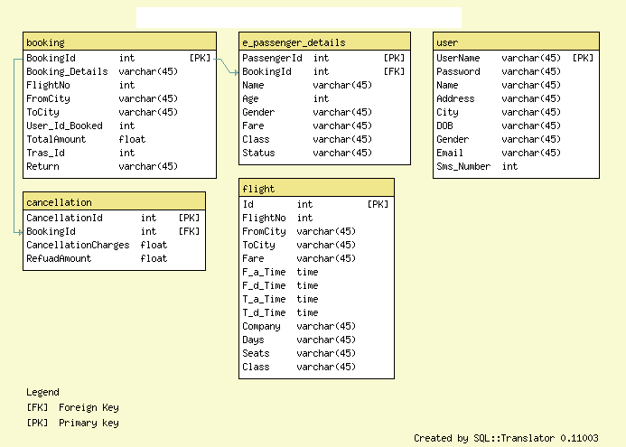
Fig.5.3

Sequence Diagram For Administrator:-

Login
Application
Database
Login
:Request
:Validate()
:executeQuery()
Response
Show Result
Failed:show()
Administrator
Success:hide()

Fig.5.4

Sequence Diagram For User:-

Login
Application
Database
Login
:Request
:Validate()
:executeQuery()
Response
Show Result
User
Success:hide()
Failed:show()

:

Fig.5.5

CHAPTER # 6
User Screens and Report
Output screens

LOGIN PAGE
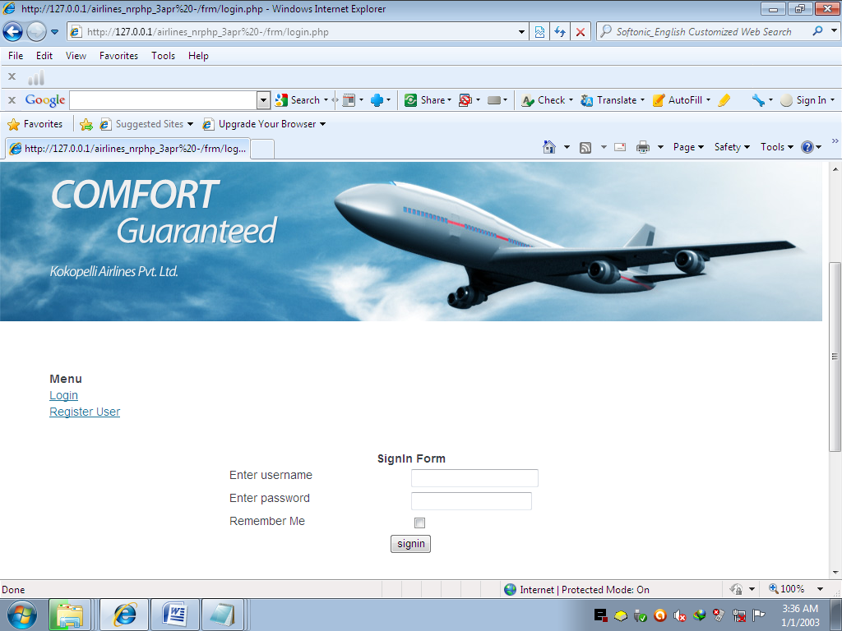

HOME PAGE
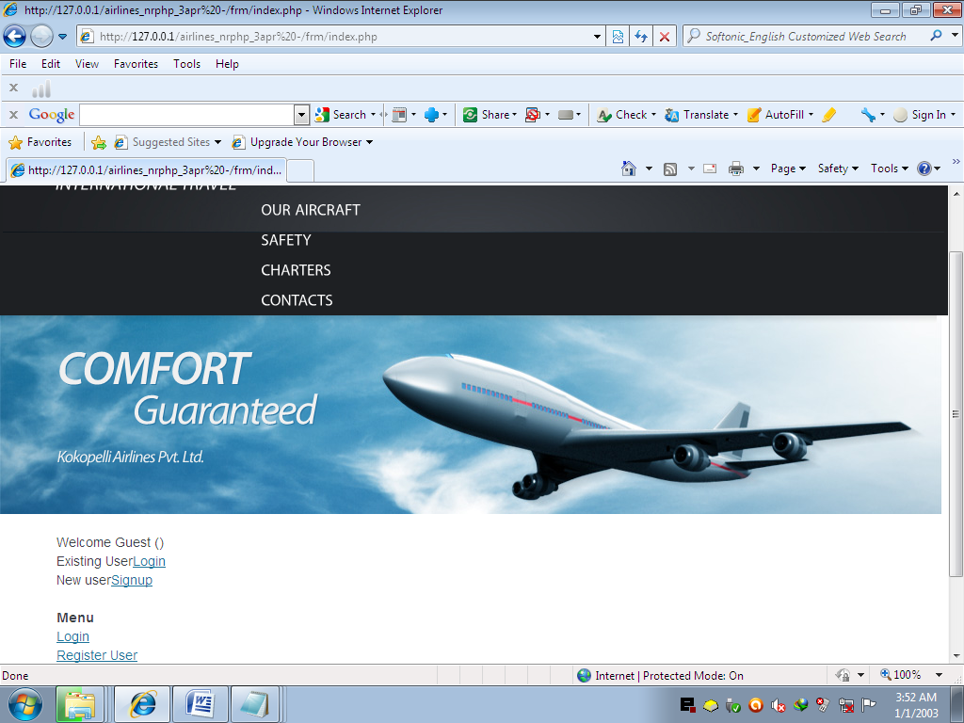

REGISTER USER PAGE
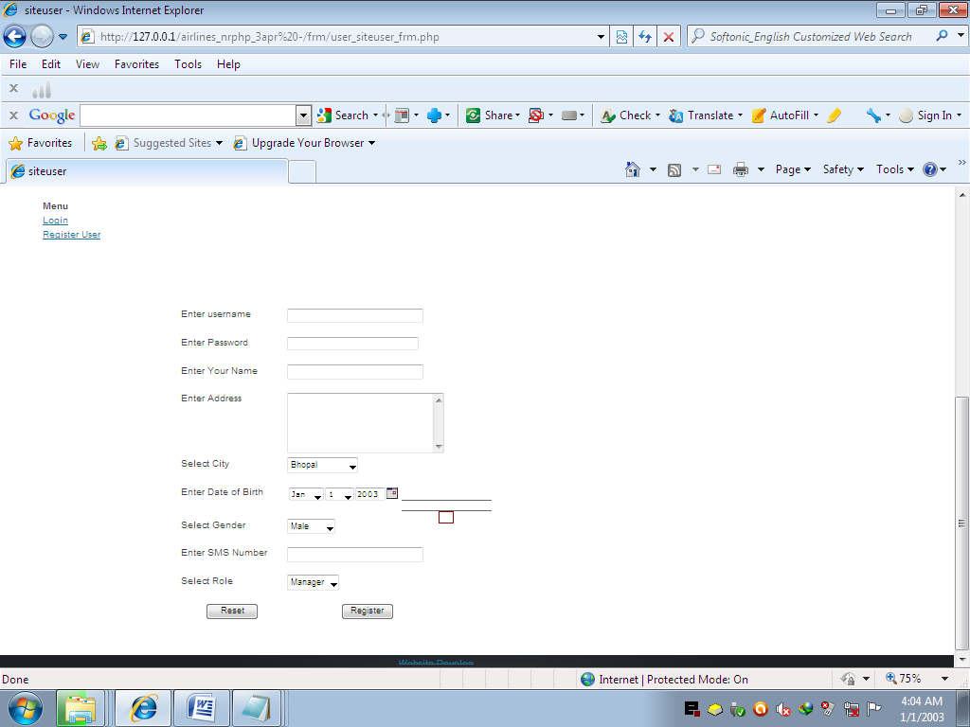

WELCOME USER PAGE
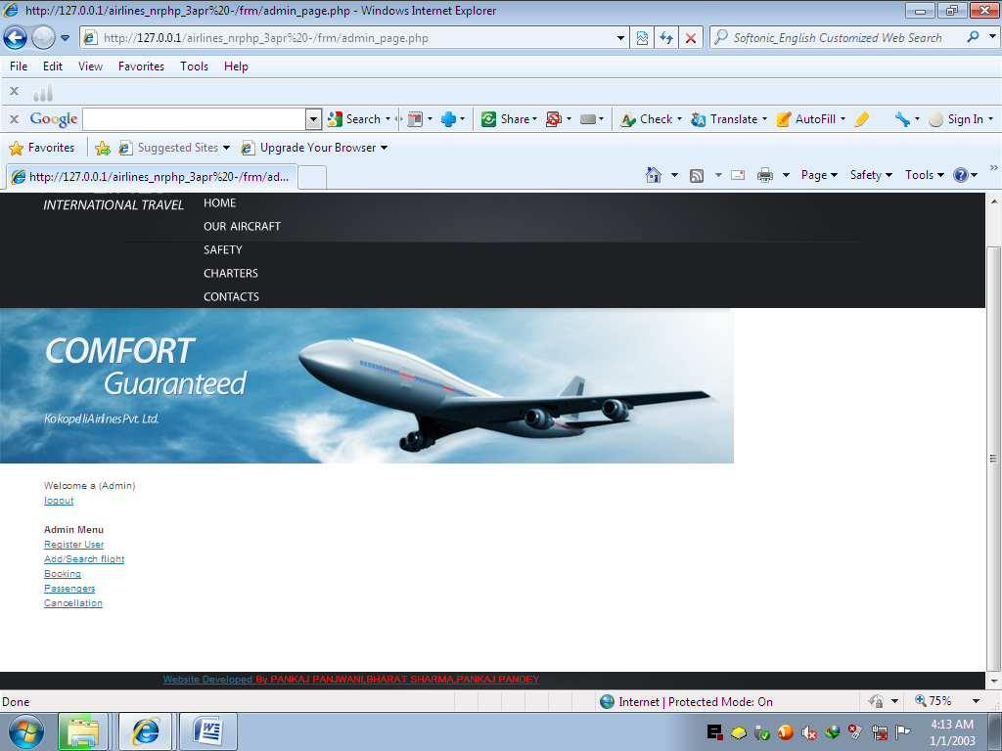

ADD/SEARCH FLIGHT
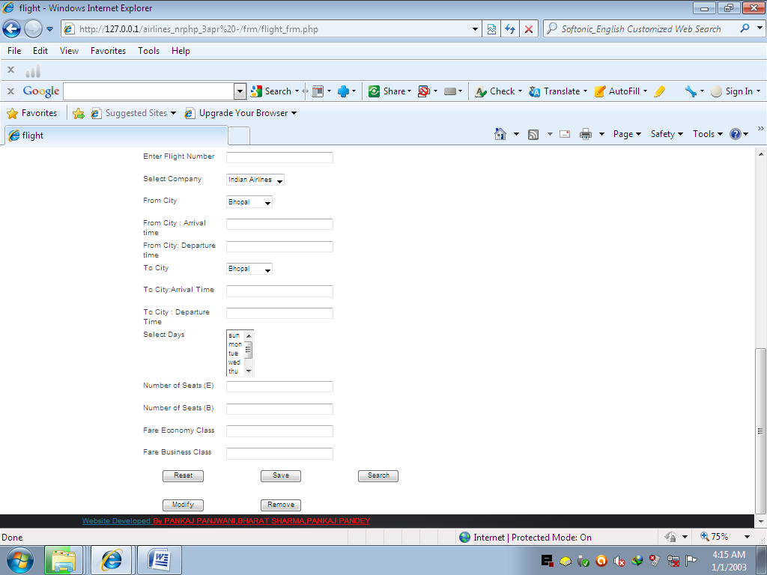

BOOKING PAGE
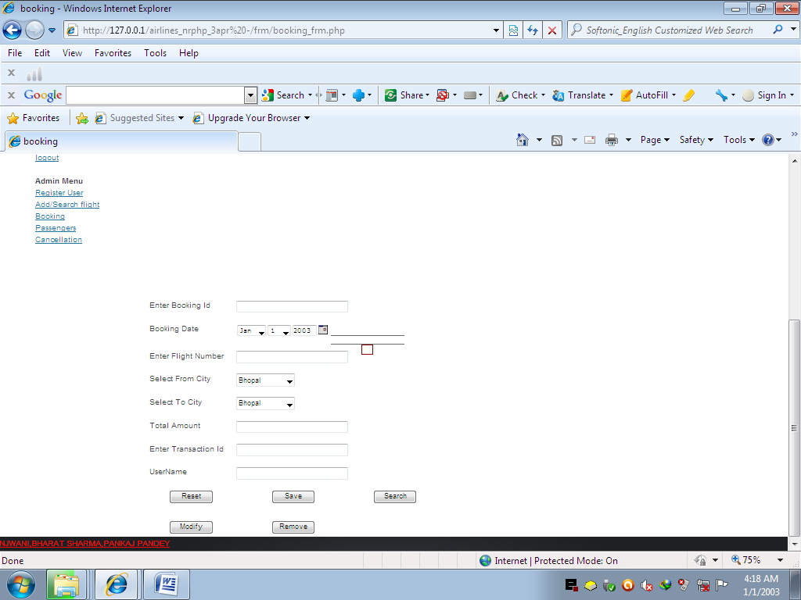

PASSENGER DATA PAGE
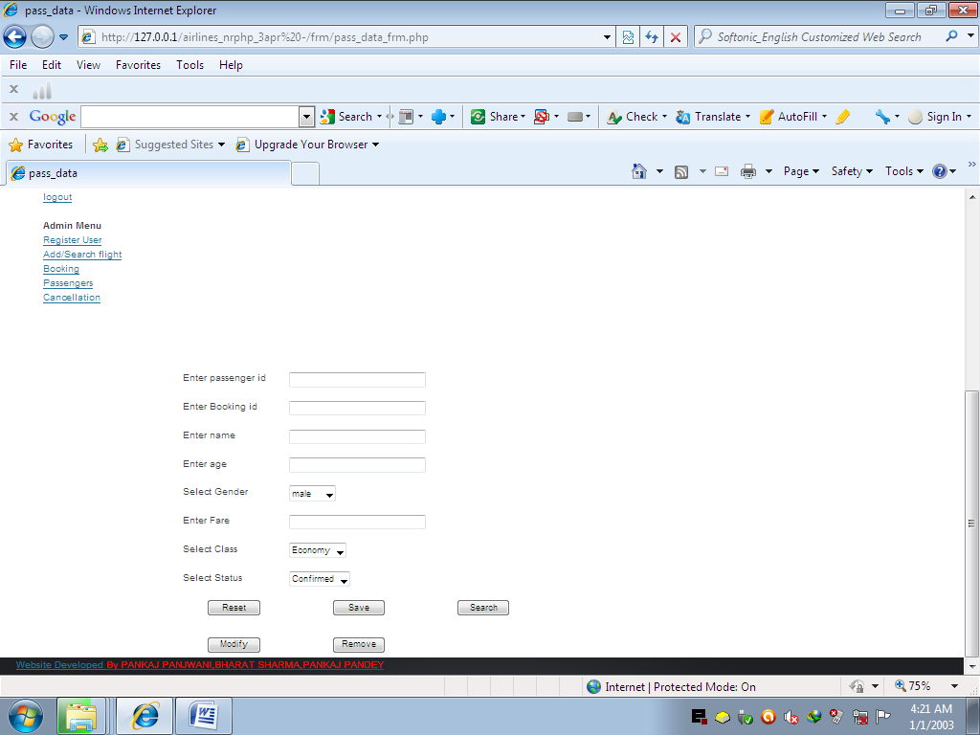

CANCELLATION PAGE
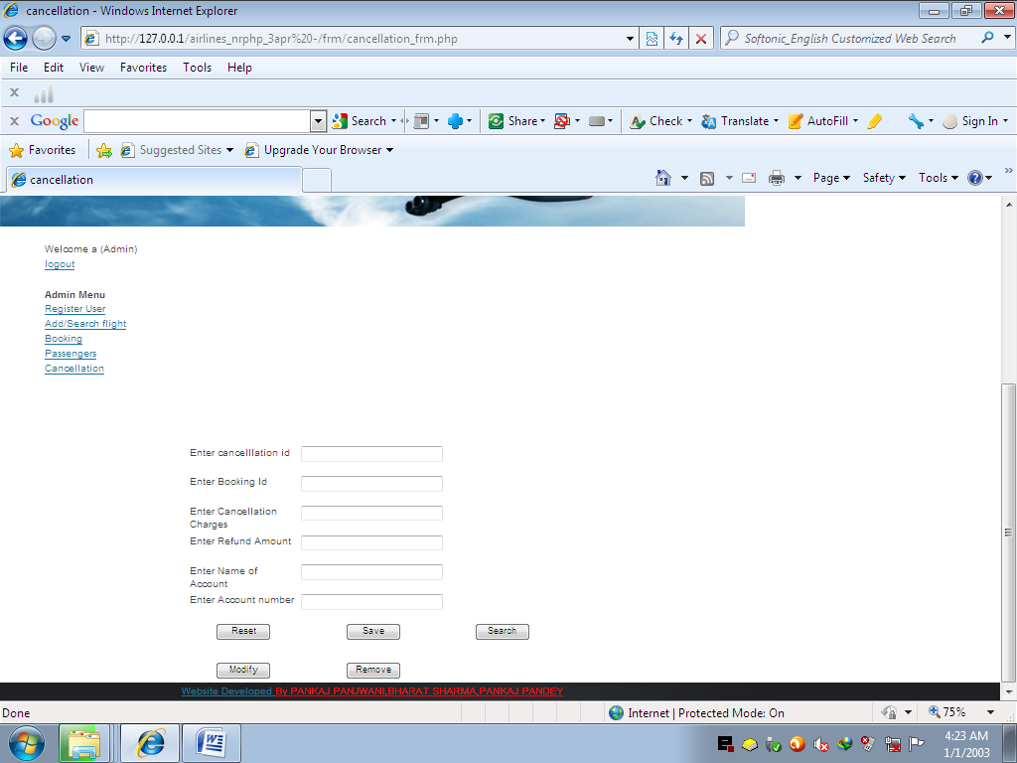

CHAPTER # 7
Coding

ADMIN PAGE CODING
<?php
@session_start();
include_once '..\dbconfig.php';
$lmsg='';
if( verifyrole('Admin')==false ) { header('Location:login.php'); }
$un=fetchusername();
$role='Anonymous';
$role=fetchrole();
$lmsg.="Welcome $un ($role) ";
if($un=='Guest') {
$lmsg.='<br/>Existing User<a href=login.php>Login</a>';
$lmsg.='<br/>New user<a href=signup.php>Signup</a>';
}
else
{
$lmsg.='<br/><a href=logout.php>logout</a>';
}
?>
<html>
<?php

if(file_exists('head_temp.php')) { include_once 'head_temp.php'; }

?>
</head><body>

<?php if(file_exists('top_temp.php')) { include_once 'top_temp.php'; } ?>
<div align="center">
<h1>
Admin Section </h1>
</div>
<?php if(file_exists('bottom_temp.php')) { include_once 'bottom_temp.php'; } ?>

LOGIN CODING
<html>
<?php
@session_start();
$lmsg="";
include_once('../dbconfig.php');
if(
isset($_REQUEST['signin']))
{
$u=$_REQUEST['uname'];
$p=$_REQUEST['upwd'];
if(isset($_REQUEST['rem']))
$r="yes";
else
$r="no";
$n=verifyuserff($u,$p,$r);
if($n==1)
{
$page=rolepage();
header("Location:$page");
}
else
{
header("Location:failure.php");
}
}

if(file_exists('head_temp.php')) { include_once 'head_temp.php'; }

?>
</head><body>

<?php if(file_exists('top_temp.php')) { include_once 'top_temp.php'; } ?>
<div align="center">
<form method="post">
<table border=0 cellspacing=4 width=450 align=center cellpadding=4 height=400>
<tr>
<td width=450 COLSPaN=2 align=center><b>SignIn Form</b></td>
</tr>
<tr>
<td width=225>Enter username (email) </td>
<td width=225><input type=text name=uname id=uname maxlength=45 /></td>
</tr>
<tr>
<td width=225>Enter password </td>
<td width=225><input type=password name=upwd id=upwd /></td>
</tr>
<tr>
<td width=225>Remember Me </td>
<td width=225><input type=checkbox name=rem id=rem value=yes /></td>
</tr>
<tr>
<td width=450 colspan=2 align=center><input type=submit name=signin id=signin value=signin />
</td>
</tr>
<tr><td colspan=2 height=300>&nbsp;</td></tr>
</table>
</form>
</div>
<?php if(file_exists('bottom_temp.php')) { include_once 'bottom_temp.php'; } ?>

BOOKING FORM CODING

<?php
@session_start();
include_once '..\dbconfig.php';
$lmsg='';
if( verifyrole('Admin')==false ) { header('Location:login.php'); }
$un=fetchusername();
$role='Anonymous';
$role=fetchrole();
$lmsg.="Welcome $un ($role) ";
if($un=='Guest') {
$lmsg.='<br/>Existing User<a href=login.php>Login</a>';
$lmsg.='<br/>New user<a href=signup.php>Signup</a>';
}
else
{
$lmsg.='<br/><a href=logout.php>logout</a>';
}
?>
<html xmlns="http://www.w3.org/1999/xhtml">
<HEAD>
<script type='text/javascript' src='../js/calendarDateInput.js'>
</script>
<script type='text/javascript' src='../js/valid1.js'>
</script>
<script language='javascript'>
function validate()
{
var ans = true;

if(document.getElementById('chkdata').value!='no')
{
ans= chk_double(document.getElementById('total_amt_err'),document.getElementById('f_total_amt'),1,document.getElementById('total_amt_msg')) && ans;

}
document.getElementById('chkdata').value='yes';
return ans;
}
</script>
<title>booking</title>
<?php if(file_exists('head_temp.php')) { include_once 'head_temp.php'; } ?>
</HEAD>
<BODY bgcolor='$bodycolor'>

<?php if(file_exists('top_temp.php')) { include_once 'top_temp.php'; } ?>

<form method=post name='booking' id='booking' onsubmit='return validate();' >

<!-- Database name is airlines<br/>Table name is booking --><div align='center'>
<table border=0 align=center bgcolor=<?php echo $tcolor; ?> cellspacing=5 cellpadding=5 width=500>
<tr bgcolor=<?php echo $hcolor; ?>>
<td colspan=3 align=center><h1>BOOKING </h1></td></tr>
<tr>
<td width=200>Enter Booking Id</td>
<TD><input type=text name=f_b_id id=f_b_id size=30 onFocus="msg(b_id_msg,'e.g. 1001');" onKeyUp="info(b_id_info,this);"
/>&nbsp;</td>
<td width=200>
<span id=b_id_msg></span>
<br/><span id=b_id_info></span>
<br/><span id=b_id_err></span>
</td>
</tr>
<tr>
<td width=200>Booking Date</td>
<TD><script>DateInput('f_b_datetime', true, 'YYYY-MM-DD')</script>&nbsp;</td>
<td width=200>
<span id=b_datetime_msg></span>
<br/><span id=b_datetime_info></span>
<br/><span id=b_datetime_err></span>
</td>
</tr>
<tr>
<td width=200>Enter Flight Number</td>
<TD><input type=text name=f_flightno id=f_flightno size=30 onFocus="msg(flightno_msg,'');" onKeyUp="info(flightno_info,this);"
/>&nbsp;</td>
<td width=200>
<span id=flightno_msg></span>
<br/><span id=flightno_info></span>
<br/><span id=flightno_err></span>
</td>
</tr>
<tr>
<td width=200>Select From City</td>
<TD><select name='f_from_city' id='f_from_city'><option value='Bhopal' > Bhopal </option><option value='Indore' > Indore </option><option value='Raipur' > Raipur </option><option value='Gwalior' > Gwalior </option><option value='Lucknow' > Lucknow </option><option value='Delhi' > Delhi </option><option value='Mumbai' > Mumbai </option><option value='Trivantpuram' > Trivantpuram </option><option value='Chennai' > Chennai </option><option value='Bangluru' > Bangluru </option><option value='Cochin' > Cochin </option><option value='Nagpur' > Nagpur </option></select>&nbsp;</td>
<td width=200>
<span id=from_city_msg></span>
<br/><span id=from_city_info></span>
<br/><span id=from_city_err></span>
</td>
</tr>
<tr>
<td width=200>Select To City</td>
<TD><select name='f_to_city' id='f_to_city'><option value='Bhopal' > Bhopal </option><option value='Indore' > Indore </option><option value='Raipur' > Raipur </option><option value='Gwalior' > Gwalior </option><option value='Lucknow' > Lucknow </option><option value='Delhi' > Delhi </option><option value='Mumbai' > Mumbai </option><option value='Trivantpuram' > Trivantpuram </option><option value='Chennai' > Chennai </option><option value='Bangluru' > Bangluru </option><option value='Cochin' > Cochin </option><option value='Nagpur' > Nagpur </option></select>&nbsp;</td>
<td width=200>
<span id=to_city_msg></span>
<br/><span id=to_city_info></span>
<br/><span id=to_city_err></span>
</td>
</tr>
<tr>
<td width=200>Total Amount</td>
<TD><input type=text name=f_total_amt id=f_total_amt size=30 onFocus="msg(total_amt_msg,'Total Amount for the ticket');" onKeyUp="info(total_amt_info,this);"
onBlur="chk_double(total_amt_err,this,1,total_amt_msg);" />&nbsp;</td>
<td width=200>
<span id=total_amt_msg></span>
<br/><span id=total_amt_info></span>
<br/><span id=total_amt_err></span>
</td>
</tr>
<tr>
<td width=200>Enter Transaction Id</td>
<TD><input type=text name=f_transaction_id id=f_transaction_id size=30 onFocus="msg(transaction_id_msg,'Trasaction id, of payment');" onKeyUp="info(transaction_id_info,this);"
/>&nbsp;</td>
<td width=200>
<span id=transaction_id_msg></span>
<br/><span id=transaction_id_info></span>
<br/><span id=transaction_id_err></span>
</td>
</tr>
<tr>
<td width=200>UserName</td>
<TD><input type=text name=f_username id=f_username size=30 onFocus="msg(username_msg,'');" onKeyUp="info(username_info,this);"
/>&nbsp;</td>
<td width=200>
<span id=username_msg></span>
<br/><span id=username_info></span>
<br/><span id=username_err></span>
</td>
</tr>
<tr>
<td align=center ><input type=reset name=reset id=reset value='Reset' style='width:75px;' /></td>
<td align=center>
<input type=hidden name=chkdata id=chkdata value=yes /><input type=submit name=add1 id=add1 value='Save' style='width:75px;' /><br/>
</td>
<td align=center>
<input type=submit name=list1 id=list1 value='Search' style='width:75px;' onclick="document.getElementById('chkdata').value='no';" /><br/>
</td>
</tr>
<tr>
<td colspan='3'>&nbsp;</td>
</tr>
<tr>
<td align=center>
<input type=submit name=modify1 id=modify1 value='Modify' style='width:75px;' /><br/>
</td>
<td align=center>
<input type=submit name=remove1 id=remove1 value='Remove' style='width:75px;' onclick="document.getElementById('chkdata').value='no';" /><br/>
</td>
</tr>
</table></div>

<?php
include '../cls/booking_cls.php' ;
if(isset($_REQUEST['add1']) || isset($_REQUEST['remove1']) || isset($_REQUEST['modify1']) || isset($_REQUEST['list1']) )
{
$cls_obj =new booking_cls();
$f_b_id = isset($_REQUEST['f_b_id']) ? $_REQUEST['f_b_id']:(isset($_FILES['f_b_id']) ? upload_file($_FILES,'f_b_id') : '') ;
$cls_obj->set_b_id($f_b_id);
$f_b_datetime = isset($_REQUEST['f_b_datetime']) ? $_REQUEST['f_b_datetime']:(isset($_FILES['f_b_datetime']) ? upload_file($_FILES,'f_b_datetime') : '') ;
$cls_obj->set_b_datetime($f_b_datetime);
$f_flightno = isset($_REQUEST['f_flightno']) ? $_REQUEST['f_flightno']:(isset($_FILES['f_flightno']) ? upload_file($_FILES,'f_flightno') : '') ;
$cls_obj->set_flightno($f_flightno);
$f_from_city = isset($_REQUEST['f_from_city']) ? $_REQUEST['f_from_city']:(isset($_FILES['f_from_city']) ? upload_file($_FILES,'f_from_city') : '') ;
$cls_obj->set_from_city($f_from_city);
$f_to_city = isset($_REQUEST['f_to_city']) ? $_REQUEST['f_to_city']:(isset($_FILES['f_to_city']) ? upload_file($_FILES,'f_to_city') : '') ;
$cls_obj->set_to_city($f_to_city);
$f_total_amt = isset($_REQUEST['f_total_amt']) ? $_REQUEST['f_total_amt']:(isset($_FILES['f_total_amt']) ? upload_file($_FILES,'f_total_amt') : '') ;
$cls_obj->set_total_amt($f_total_amt);
$f_transaction_id = isset($_REQUEST['f_transaction_id']) ? $_REQUEST['f_transaction_id']:(isset($_FILES['f_transaction_id']) ? upload_file($_FILES,'f_transaction_id') : '') ;
$cls_obj->set_transaction_id($f_transaction_id);
$f_username = isset($_REQUEST['f_username']) ? $_REQUEST['f_username']:(isset($_FILES['f_username']) ? upload_file($_FILES,'f_username') : '') ;
$cls_obj->set_username($f_username);
}
if(isset($_REQUEST['add1']))
{
$cls_obj->savedata() ;
}
if(isset($_REQUEST['modify1']))
{
$cls_obj->modifydata() ;
}
if(isset($_REQUEST['remove1']))
{
$cls_obj->removedata() ;
}
if(isset($_REQUEST['list1']))
{
$cls_obj->searchdata() ;
}
?>

</form>
<?php if(file_exists('bottom_temp.php')) { include_once 'bottom_temp.php'; } ?>
</BODY>
</HTML>

CANELLATION FORM CODING

<?php
@session_start();
include_once '..\dbconfig.php';
$lmsg='';
if( verifyrole('Admin')==false ) { header('Location:login.php'); }
$un=fetchusername();
$role='Anonymous';
$role=fetchrole();
$lmsg.="Welcome $un ($role) ";
if($un=='Guest') {
$lmsg.='<br/>Existing User<a href=login.php>Login</a>';
$lmsg.='<br/>New user<a href=signup.php>Signup</a>';
}
else
{
$lmsg.='<br/><a href=logout.php>logout</a>';
}
?>
<html xmlns="http://www.w3.org/1999/xhtml">
<HEAD>
<script type='text/javascript' src='../js/calendarDateInput.js'>
</script>
<script type='text/javascript' src='../js/valid1.js'>
</script>
<script language='javascript'>
function validate()
{
var ans = true;

if(document.getElementById('chkdata').value!='no')
{
}
document.getElementById('chkdata').value='yes';
return ans;
}
</script>
<title>cancellation</title>
<?php if(file_exists('head_temp.php')) { include_once 'head_temp.php'; } ?>
</HEAD>
<BODY bgcolor='$bodycolor'>

<?php if(file_exists('top_temp.php')) { include_once 'top_temp.php'; } ?>

<form method=post name='cancellation' id='cancellation' onsubmit='return validate();' >

<!-- Database name is airlines<br/>Table name is cancellation --><div align='center'>
<table border=0 align=center bgcolor=<?php echo $tcolor; ?> cellspacing=5 cellpadding=5 width=500>
<tr bgcolor=<?php echo $hcolor; ?>>
<td colspan=3 align=center><h1>CANCELLATION </h1></td></tr>
<tr>
<td width=200>Enter cancelllation id</td>
<TD><input type=text name=f_c_id id=f_c_id size=30 onFocus="msg(c_id_msg,'e.g. 101');" onKeyUp="info(c_id_info,this);"
/>&nbsp;</td>
<td width=200>
<span id=c_id_msg></span>
<br/><span id=c_id_info></span>
<br/><span id=c_id_err></span>
</td>
</tr>
<tr>
<td width=200>Enter Booking Id</td>
<TD><input type=text name=f_b_id id=f_b_id size=30 onFocus="msg(b_id_msg,'enter corresponding booking id');" onKeyUp="info(b_id_info,this);"
/>&nbsp;</td>
<td width=200>
<span id=b_id_msg></span>
<br/><span id=b_id_info></span>
<br/><span id=b_id_err></span>
</td>
</tr>
<tr>
<td width=200>Enter Cancellation Charges</td>
<TD><input type=text name=f_cancel_charges id=f_cancel_charges size=30 onFocus="msg(cancel_charges_msg,'Enter Cancellation Charges');" onKeyUp="info(cancel_charges_info,this);"
/>&nbsp;</td>
<td width=200>
<span id=cancel_charges_msg></span>
<br/><span id=cancel_charges_info></span>
<br/><span id=cancel_charges_err></span>
</td>
</tr>
<tr>
<td width=200>Enter Refund Amount</td>
<TD><input type=text name=f_refund_amt id=f_refund_amt size=30 onFocus="msg(refund_amt_msg,'Enter Refund chargess');" onKeyUp="info(refund_amt_info,this);"
/>&nbsp;</td>
<td width=200>
<span id=refund_amt_msg></span>
<br/><span id=refund_amt_info></span>
<br/><span id=refund_amt_err></span>
</td>
</tr>
<tr>
<td width=200>Enter Name of Account</td>
<TD><input type=text name=f_name id=f_name size=30 onFocus="msg(name_msg,'e.g. Amit Kumar');" onKeyUp="info(name_info,this);"
/>&nbsp;</td>
<td width=200>
<span id=name_msg></span>
<br/><span id=name_info></span>
<br/><span id=name_err></span>
</td>
</tr>
<tr>
<td width=200>Enter Account number</td>
<TD><input type=text name=f_accno id=f_accno size=30 onFocus="msg(accno_msg,'e.g. 1244215');" onKeyUp="info(accno_info,this);"
/>&nbsp;</td>
<td width=200>
<span id=accno_msg></span>
<br/><span id=accno_info></span>
<br/><span id=accno_err></span>
</td>
</tr>
<tr>
<td align=center ><input type=reset name=reset id=reset value='Reset' style='width:75px;' /></td>
<td align=center>
<input type=hidden name=chkdata id=chkdata value=yes /><input type=submit name=add1 id=add1 value='Save' style='width:75px;' /><br/>
</td>
<td align=center>
<input type=submit name=list1 id=list1 value='Search' style='width:75px;' onclick="document.getElementById('chkdata').value='no';" /><br/>
</td>
</tr>
<tr>
<td colspan='3'>&nbsp;</td>
</tr>
<tr>
<td align=center>
<input type=submit name=modify1 id=modify1 value='Modify' style='width:75px;' /><br/>
</td>
<td align=center>
<input type=submit name=remove1 id=remove1 value='Remove' style='width:75px;' onclick="document.getElementById('chkdata').value='no';" /><br/>
</td>
</tr>
</table></div>

<?php
include '../cls/cancellation_cls.php' ;
if(isset($_REQUEST['add1']) || isset($_REQUEST['remove1']) || isset($_REQUEST['modify1']) || isset($_REQUEST['list1']) )
{
$cls_obj =new cancellation_cls();
$f_c_id = isset($_REQUEST['f_c_id']) ? $_REQUEST['f_c_id']:(isset($_FILES['f_c_id']) ? upload_file($_FILES,'f_c_id') : '') ;
$cls_obj->set_c_id($f_c_id);
$f_b_id = isset($_REQUEST['f_b_id']) ? $_REQUEST['f_b_id']:(isset($_FILES['f_b_id']) ? upload_file($_FILES,'f_b_id') : '') ;
$cls_obj->set_b_id($f_b_id);
$f_cancel_charges = isset($_REQUEST['f_cancel_charges']) ? $_REQUEST['f_cancel_charges']:(isset($_FILES['f_cancel_charges']) ? upload_file($_FILES,'f_cancel_charges') : '') ;
$cls_obj->set_cancel_charges($f_cancel_charges);
$f_refund_amt = isset($_REQUEST['f_refund_amt']) ? $_REQUEST['f_refund_amt']:(isset($_FILES['f_refund_amt']) ? upload_file($_FILES,'f_refund_amt') : '') ;
$cls_obj->set_refund_amt($f_refund_amt);
$f_name = isset($_REQUEST['f_name']) ? $_REQUEST['f_name']:(isset($_FILES['f_name']) ? upload_file($_FILES,'f_name') : '') ;
$cls_obj->set_name($f_name);
$f_accno = isset($_REQUEST['f_accno']) ? $_REQUEST['f_accno']:(isset($_FILES['f_accno']) ? upload_file($_FILES,'f_accno') : '') ;
$cls_obj->set_accno($f_accno);
}
if(isset($_REQUEST['add1']))
{
$cls_obj->savedata() ;
}
if(isset($_REQUEST['modify1']))
{
$cls_obj->modifydata() ;
}
if(isset($_REQUEST['remove1']))
{
$cls_obj->removedata() ;
}
if(isset($_REQUEST['list1']))
{
$cls_obj->searchdata() ;
}
?>

</form>
<?php if(file_exists('bottom_temp.php')) { include_once 'bottom_temp.php'; } ?>
</BODY>
</HTML>

LOGIN FAILED
<html>
<?php
$lmsg="";

if(file_exists('head_temp.php')) { include_once 'head_temp.php'; }

?>
</head><body>

<?php if(file_exists('top_temp.php')) { include_once 'top_temp.php'; } ?>
<div align="center">
<h1>Login Failed </h1>
</div>
<?php if(file_exists('bottom_temp.php')) { include_once 'bottom_temp.php'; } ?>

LOGOUT CODING

<?php
@session_start();
$_SESSION['sun']="";
$_SESSION['sp']="";
@session_destroy();
setcookie('cun',"",time()-60*60*24*7);
setcookie('cp',"",time()-60*60*24*7);
header("Location:login.php");
?>

FLIGHT FORM CODING
<?php
@session_start();
include_once '..\dbconfig.php';
$lmsg='';
if( verifyrole('Admin')==false ) { header('Location:login.php'); }
$un=fetchusername();
$role='Anonymous';
$role=fetchrole();
$lmsg.="Welcome $un ($role) ";
if($un=='Guest') {
$lmsg.='<br/>Existing User<a href=login.php>Login</a>';
$lmsg.='<br/>New user<a href=signup.php>Signup</a>';
}
else
{
$lmsg.='<br/><a href=logout.php>logout</a>';
}
?>
<html xmlns="http://www.w3.org/1999/xhtml">
<HEAD>
<script type='text/javascript' src='../js/calendarDateInput.js'>
</script>
<script type='text/javascript' src='../js/valid1.js'>
</script>
<script language='javascript'>
function validate()
{
var ans = true;

if(document.getElementById('chkdata').value!='no')
{
ans= chk_alpha(document.getElementById('flightno_err'),document.getElementById('f_flightno'),3,document.getElementById('flightno_msg')) && ans;

}
document.getElementById('chkdata').value='yes';
return ans;
}
</script>
<title>flight</title>
<?php if(file_exists('head_temp.php')) { include_once 'head_temp.php'; } ?>
</HEAD>
<BODY bgcolor='$bodycolor'>

<?php if(file_exists('top_temp.php')) { include_once 'top_temp.php'; } ?>

<form method=post name='flight' id='flight' onsubmit='return validate();' >

<!-- Database name is airlines<br/>Table name is flight --><div align='center'>
<table border=0 align=center bgcolor=<?php echo $tcolor; ?> cellspacing=5 cellpadding=5 width=500>
<tr bgcolor=<?php echo $hcolor; ?>>
<td colspan=3 align=center><h1>FLIGHT </h1></td></tr>
<tr>
<td width=200>Enter Flight id</td>
<TD><input type=text name=f_fid id=f_fid size=30 onFocus="msg(fid_msg,'numeric Digits only');" onKeyUp="info(fid_info,this);"
/>&nbsp;</td>
<td width=200>
<span id=fid_msg></span>
<br/><span id=fid_info></span>
<br/><span id=fid_err></span>
</td>
</tr>
<tr>
<td width=200>Enter Flight Number</td>
<TD><input type=text name=f_flightno id=f_flightno size=30 onFocus="msg(flightno_msg,'e.g. AB124');" onKeyUp="info(flightno_info,this);"
onBlur="chk_alpha(flightno_err,this,3,flightno_msg);" />&nbsp;</td>
<td width=200>
<span id=flightno_msg></span>
<br/><span id=flightno_info></span>
<br/><span id=flightno_err></span>
</td>
</tr>
<tr>
<td width=200>Select Company</td>
<TD><select name='f_company' id='f_company'><option value='Indian Airlines' > Indian Airlines </option><option value='IndiGo' > IndiGo </option><option value='JetAirways' > JetAirways </option><option value='Lomg Fisher' > Lomg Fisher </option></select>&nbsp;</td>
<td width=200>
<span id=company_msg></span>
<br/><span id=company_info></span>
<br/><span id=company_err></span>
</td>
</tr>
<tr>
<td width=200>From City</td>
<TD><select name='f_fromcity' id='f_fromcity'><option value='Bhopal' > Bhopal </option><option value='Mumbai' > Mumbai </option><option value='Indore' > Indore </option><option value='Gwalior' > Gwalior </option><option value='Raipur' > Raipur </option><option value='Jabalpur' > Jabalpur </option><option value='New Delhi' > New Delhi </option><option value='Chennai' > Chennai </option><option value=' Kolkatta' > Kolkatta </option></select>&nbsp;</td>
<td width=200>
<span id=fromcity_msg></span>
<br/><span id=fromcity_info></span>
<br/><span id=fromcity_err></span>
</td>
</tr>
<tr>
<td width=200>From City : Arrival time</td>
<TD><input type=text name=f_from_atime id=f_from_atime size=30 onFocus="msg(from_atime_msg,'time format HH:MM:SS');" onKeyUp="info(from_atime_info,this);"
/>&nbsp;</td>
<td width=200>
<span id=from_atime_msg></span>
<br/><span id=from_atime_info></span>
<br/><span id=from_atime_err></span>
</td>
</tr>
<tr>
<td width=200>From City: Departure time</td>
<TD><input type=text name=f_from_dtime id=f_from_dtime size=30 onFocus="msg(from_dtime_msg,'time format HH:MM:SS');" onKeyUp="info(from_dtime_info,this);"
/>&nbsp;</td>
<td width=200>
<span id=from_dtime_msg></span>
<br/><span id=from_dtime_info></span>
<br/><span id=from_dtime_err></span>
</td>
</tr>
<tr>
<td width=200>To City</td>
<TD><select name='f_tocity' id='f_tocity'><option value='Bhopal' > Bhopal </option><option value='Mumbai' > Mumbai </option><option value='Indore' > Indore </option><option value='Gwalior' > Gwalior </option><option value='Raipur' > Raipur </option><option value='Jabalpur' > Jabalpur </option><option value='New Delhi' > New Delhi </option><option value='Chennai' > Chennai </option><option value=' Kolkatta' > Kolkatta </option></select>&nbsp;</td>
<td width=200>
<span id=tocity_msg></span>
<br/><span id=tocity_info></span>
<br/><span id=tocity_err></span>
</td>
</tr>
<tr>
<td width=200>To City:Arrival Time</td>
<TD><input type=text name=f_to_atime id=f_to_atime size=30 onFocus="msg(to_atime_msg,'time format HH:MM:SS');" onKeyUp="info(to_atime_info,this);"
/>&nbsp;</td>
<td width=200>
<span id=to_atime_msg></span>
<br/><span id=to_atime_info></span>
<br/><span id=to_atime_err></span>
</td>
</tr>
<tr>
<td width=200>To City : Departure Time</td>
<TD><input type=text name=f_to_dtime id=f_to_dtime size=30 onFocus="msg(to_dtime_msg,'time format HH:MM:SS');" onKeyUp="info(to_dtime_info,this);"
/>&nbsp;</td>
<td width=200>
<span id=to_dtime_msg></span>
<br/><span id=to_dtime_info></span>
<br/><span id=to_dtime_err></span>
</td>
</tr>
<tr>
<td width=200>Select Days</td>
<TD><select name='f_days' id='f_days' size=5 multiple><option value='sun' > sun </option><option value='mon' > mon </option><option value='tue' > tue </option><option value='wed' > wed </option><option value='thu' > thu </option><option value='fri' > fri </option><option value='sat' > sat </option></select>&nbsp;</td>
<td width=200>
<span id=days_msg></span>
<br/><span id=days_info></span>
<br/><span id=days_err></span>
</td>
</tr>
<tr>
<td width=200>Number of Seats (E)</td>
<TD><input type=text name=f_seats_e id=f_seats_e size=30 onFocus="msg(seats_e_msg,'ECONOMY CLASS');" onKeyUp="info(seats_e_info,this);"
/>&nbsp;</td>
<td width=200>
<span id=seats_e_msg></span>
<br/><span id=seats_e_info></span>
<br/><span id=seats_e_err></span>
</td>
</tr>
<tr>
<td width=200>Number of Seats (B)</td>
<TD><input type=text name=f_seats_o id=f_seats_o size=30 onFocus="msg(seats_o_msg,'COMFORT CLASS');" onKeyUp="info(seats_o_info,this);"
/>&nbsp;</td>
<td width=200>
<span id=seats_o_msg></span>
<br/><span id=seats_o_info></span>
<br/><span id=seats_o_err></span>
</td>
</tr>
<tr>
<td width=200>Fare Economy Class</td>
<TD><input type=text name=f_fare_e id=f_fare_e size=30 onFocus="msg(fare_e_msg,'in INR');" onKeyUp="info(fare_e_info,this);"
/>&nbsp;</td>
<td width=200>
<span id=fare_e_msg></span>
<br/><span id=fare_e_info></span>
<br/><span id=fare_e_err></span>
</td>
</tr>
<tr>
<td width=200>Fare Business Class</td>
<TD><input type=text name=f_fare_b id=f_fare_b size=30 onFocus="msg(fare_b_msg,'in INR');" onKeyUp="info(fare_b_info,this);"
/>&nbsp;</td>
<td width=200>
<span id=fare_b_msg></span>
<br/><span id=fare_b_info></span>
<br/><span id=fare_b_err></span>
</td>
</tr>
<tr>
<td align=center ><input type=reset name=reset id=reset value='Reset' style='width:75px;' /></td>
<td align=center>
<input type=hidden name=chkdata id=chkdata value=yes /><input type=submit name=add1 id=add1 value='Save' style='width:75px;' /><br/>
</td>
<td align=center>
<input type=submit name=list1 id=list1 value='Search' style='width:75px;' onclick="document.getElementById('chkdata').value='no';" /><br/>
</td>
</tr>
<tr>
<td colspan='3'>&nbsp;</td>
</tr>
<tr>
<td align=center>
<input type=submit name=modify1 id=modify1 value='Modify' style='width:75px;' /><br/>
</td>
<td align=center>
<input type=submit name=remove1 id=remove1 value='Remove' style='width:75px;' onclick="document.getElementById('chkdata').value='no';" /><br/>
</td>
</tr>
</table></div>

<?php
include '../cls/flight_cls.php' ;
if(isset($_REQUEST['add1']) || isset($_REQUEST['remove1']) || isset($_REQUEST['modify1']) || isset($_REQUEST['list1']) )
{
$cls_obj =new flight_cls();
$f_fid = isset($_REQUEST['f_fid']) ? $_REQUEST['f_fid']:(isset($_FILES['f_fid']) ? upload_file($_FILES,'f_fid') : '') ;
$cls_obj->set_fid($f_fid);
$f_flightno = isset($_REQUEST['f_flightno']) ? $_REQUEST['f_flightno']:(isset($_FILES['f_flightno']) ? upload_file($_FILES,'f_flightno') : '') ;
$cls_obj->set_flightno($f_flightno);
$f_company = isset($_REQUEST['f_company']) ? $_REQUEST['f_company']:(isset($_FILES['f_company']) ? upload_file($_FILES,'f_company') : '') ;
$cls_obj->set_company($f_company);
$f_fromcity = isset($_REQUEST['f_fromcity']) ? $_REQUEST['f_fromcity']:(isset($_FILES['f_fromcity']) ? upload_file($_FILES,'f_fromcity') : '') ;
$cls_obj->set_fromcity($f_fromcity);
$f_from_atime = isset($_REQUEST['f_from_atime']) ? $_REQUEST['f_from_atime']:(isset($_FILES['f_from_atime']) ? upload_file($_FILES,'f_from_atime') : '') ;
$cls_obj->set_from_atime($f_from_atime);
$f_from_dtime = isset($_REQUEST['f_from_dtime']) ? $_REQUEST['f_from_dtime']:(isset($_FILES['f_from_dtime']) ? upload_file($_FILES,'f_from_dtime') : '') ;
$cls_obj->set_from_dtime($f_from_dtime);
$f_tocity = isset($_REQUEST['f_tocity']) ? $_REQUEST['f_tocity']:(isset($_FILES['f_tocity']) ? upload_file($_FILES,'f_tocity') : '') ;
$cls_obj->set_tocity($f_tocity);
$f_to_atime = isset($_REQUEST['f_to_atime']) ? $_REQUEST['f_to_atime']:(isset($_FILES['f_to_atime']) ? upload_file($_FILES,'f_to_atime') : '') ;
$cls_obj->set_to_atime($f_to_atime);
$f_to_dtime = isset($_REQUEST['f_to_dtime']) ? $_REQUEST['f_to_dtime']:(isset($_FILES['f_to_dtime']) ? upload_file($_FILES,'f_to_dtime') : '') ;
$cls_obj->set_to_dtime($f_to_dtime);
$f_days = isset($_REQUEST['f_days']) ? $_REQUEST['f_days']:(isset($_FILES['f_days']) ? upload_file($_FILES,'f_days') : '') ;
$cls_obj->set_days($f_days);
$f_seats_e = isset($_REQUEST['f_seats_e']) ? $_REQUEST['f_seats_e']:(isset($_FILES['f_seats_e']) ? upload_file($_FILES,'f_seats_e') : '') ;
$cls_obj->set_seats_e($f_seats_e);
$f_seats_o = isset($_REQUEST['f_seats_o']) ? $_REQUEST['f_seats_o']:(isset($_FILES['f_seats_o']) ? upload_file($_FILES,'f_seats_o') : '') ;
$cls_obj->set_seats_o($f_seats_o);
$f_fare_e = isset($_REQUEST['f_fare_e']) ? $_REQUEST['f_fare_e']:(isset($_FILES['f_fare_e']) ? upload_file($_FILES,'f_fare_e') : '') ;
$cls_obj->set_fare_e($f_fare_e);
$f_fare_b = isset($_REQUEST['f_fare_b']) ? $_REQUEST['f_fare_b']:(isset($_FILES['f_fare_b']) ? upload_file($_FILES,'f_fare_b') : '') ;
$cls_obj->set_fare_b($f_fare_b);
}
if(isset($_REQUEST['add1']))
{
$cls_obj->savedata() ;
}
if(isset($_REQUEST['modify1']))
{
$cls_obj->modifydata() ;
}
if(isset($_REQUEST['remove1']))
{
$cls_obj->removedata() ;
}
if(isset($_REQUEST['list1']))
{
$cls_obj->searchdata() ;
}
?>

</form>
<?php if(file_exists('bottom_temp.php')) { include_once 'bottom_temp.php'; } ?>
</BODY>
</HTML>

MANAGER PAGE CODING
<?php
@session_start();
include_once '..\dbconfig.php';
$lmsg='';
if( verifyrole('Manager')==false ) { header('Location:login.php'); }
$un=fetchusername();
$role='Anonymous';
$role=fetchrole();
$lmsg.="Welcome $un ($role) ";
if($un=='Guest') {
$lmsg.='<br/>Existing User<a href=login.php>Login</a>';
$lmsg.='<br/>New user<a href=signup.php>Signup</a>';
}
else
{
$lmsg.='<br/><a href=logout.php>logout</a>';
}
?>
<html>
<?php

if(file_exists('head_temp.php')) { include_once 'head_temp.php'; }

?>
</head><body>

<?php if(file_exists('top_temp.php')) { include_once 'top_temp.php'; } ?>
<div align="center">
<h1>
User Section </h1>
</div>
<?php if(file_exists('bottom_temp.php')) { include_once 'bottom_temp.php'; } ?>
PASSENGER_DATA FORM CODING
<?php
@session_start();
include_once '..\dbconfig.php';
$lmsg='';
if( verifyrole('Admin')==false ) { header('Location:login.php'); }
$un=fetchusername();
$role='Anonymous';
$role=fetchrole();
$lmsg.="Welcome $un ($role) ";
if($un=='Guest') {
$lmsg.='<br/>Existing User<a href=login.php>Login</a>';
$lmsg.='<br/>New user<a href=signup.php>Signup</a>';
}
else
{
$lmsg.='<br/><a href=logout.php>logout</a>';
}
?>
<html xmlns="http://www.w3.org/1999/xhtml">
<HEAD>
<script type='text/javascript' src='../js/calendarDateInput.js'>
</script>
<script type='text/javascript' src='../js/valid1.js'>
</script>
<script language='javascript'>
function validate()
{
var ans = true;

if(document.getElementById('chkdata').value!='no')
{
ans= chk_alpha(document.getElementById('name_err'),document.getElementById('f_name'),2,document.getElementById('name_msg')) && ans;

}
document.getElementById('chkdata').value='yes';
return ans;
}
</script>
<title>pass_data</title>
<?php if(file_exists('head_temp.php')) { include_once 'head_temp.php'; } ?>
</HEAD>
<BODY bgcolor='$bodycolor'>

<?php if(file_exists('top_temp.php')) { include_once 'top_temp.php'; } ?>

<form method=post name='pass_data' id='pass_data' onsubmit='return validate();' >

<!-- Database name is airlines<br/>Table name is pass_data --><div align='center'>
<table border=0 align=center bgcolor=<?php echo $tcolor; ?> cellspacing=5 cellpadding=5 width=500>
<tr bgcolor=<?php echo $hcolor; ?>>
<td colspan=3 align=center><h1>PASS_DATA </h1></td></tr>
<tr>
<td width=200>Enter passenger id</td>
<TD><input type=text name=f_pass_id id=f_pass_id size=30 onFocus="msg(pass_id_msg,'e.g. 101');" onKeyUp="info(pass_id_info,this);"
/>&nbsp;</td>
<td width=200>
<span id=pass_id_msg></span>
<br/><span id=pass_id_info></span>
<br/><span id=pass_id_err></span>
</td>
</tr>
<tr>
<td width=200>Enter Booking id</td>
<TD><input type=text name=f_book_id id=f_book_id size=30 onFocus="msg(book_id_msg,'booking id , exisitng');" onKeyUp="info(book_id_info,this);"
/>&nbsp;</td>
<td width=200>
<span id=book_id_msg></span>
<br/><span id=book_id_info></span>
<br/><span id=book_id_err></span>
</td>
</tr>
<tr>
<td width=200>Enter name </td>
<TD><input type=text name=f_name id=f_name size=30 onFocus="msg(name_msg,'e.g Rajesh Kumar');" onKeyUp="info(name_info,this);"
onBlur="chk_alpha(name_err,this,2,name_msg);" />&nbsp;</td>
<td width=200>
<span id=name_msg></span>
<br/><span id=name_info></span>
<br/><span id=name_err></span>
</td>
</tr>
<tr>
<td width=200>Enter age</td>
<TD><input type=text name=f_age id=f_age size=30 onFocus="msg(age_msg,'in years');" onKeyUp="info(age_info,this);"
/>&nbsp;</td>
<td width=200>
<span id=age_msg></span>
<br/><span id=age_info></span>
<br/><span id=age_err></span>
</td>
</tr>
<tr>
<td width=200>Select Gender</td>
<TD><select name='f_gender' id='f_gender'><option value='male' > male </option><option value='female' > female </option></select>&nbsp;</td>
<td width=200>
<span id=gender_msg></span>
<br/><span id=gender_info></span>
<br/><span id=gender_err></span>
</td>
</tr>
<tr>
<td width=200>Enter Fare</td>
<TD><input type=text name=f_fare id=f_fare size=30 onFocus="msg(fare_msg,'');" onKeyUp="info(fare_info,this);"
/>&nbsp;</td>
<td width=200>
<span id=fare_msg></span>
<br/><span id=fare_info></span>
<br/><span id=fare_err></span>
</td>
</tr>
<tr>
<td width=200>Select Class</td>
<TD><select name='f_class' id='f_class'><option value='Economy' > Economy </option><option value=' Comfort' > Comfort </option></select>&nbsp;</td>
<td width=200>
<span id=class_msg></span>
<br/><span id=class_info></span>
<br/><span id=class_err></span>
</td>
</tr>
<tr>
<td width=200>Select Status</td>
<TD><select name='f_status' id='f_status'><option value='Confirmed' > Confirmed </option><option value='Waiting' > Waiting </option></select>&nbsp;</td>
<td width=200>
<span id=status_msg></span>
<br/><span id=status_info></span>
<br/><span id=status_err></span>
</td>
</tr>
<tr>
<td align=center ><input type=reset name=reset id=reset value='Reset' style='width:75px;' /></td>
<td align=center>
<input type=hidden name=chkdata id=chkdata value=yes /><input type=submit name=add1 id=add1 value='Save' style='width:75px;' /><br/>
</td>
<td align=center>
<input type=submit name=list1 id=list1 value='Search' style='width:75px;' onclick="document.getElementById('chkdata').value='no';" /><br/>
</td>
</tr>
<tr>
<td colspan='3'>&nbsp;</td>
</tr>
<tr>
<td align=center>
<input type=submit name=modify1 id=modify1 value='Modify' style='width:75px;' /><br/>
</td>
<td align=center>
<input type=submit name=remove1 id=remove1 value='Remove' style='width:75px;' onclick="document.getElementById('chkdata').value='no';" /><br/>
</td>
</tr>
</table></div>

<?php
include '../cls/pass_data_cls.php' ;
if(isset($_REQUEST['add1']) || isset($_REQUEST['remove1']) || isset($_REQUEST['modify1']) || isset($_REQUEST['list1']) )
{
$cls_obj =new pass_data_cls();
$f_pass_id = isset($_REQUEST['f_pass_id']) ? $_REQUEST['f_pass_id']:(isset($_FILES['f_pass_id']) ? upload_file($_FILES,'f_pass_id') : '') ;
$cls_obj->set_pass_id($f_pass_id);
$f_book_id = isset($_REQUEST['f_book_id']) ? $_REQUEST['f_book_id']:(isset($_FILES['f_book_id']) ? upload_file($_FILES,'f_book_id') : '') ;
$cls_obj->set_book_id($f_book_id);
$f_name = isset($_REQUEST['f_name']) ? $_REQUEST['f_name']:(isset($_FILES['f_name']) ? upload_file($_FILES,'f_name') : '') ;
$cls_obj->set_name($f_name);
$f_age = isset($_REQUEST['f_age']) ? $_REQUEST['f_age']:(isset($_FILES['f_age']) ? upload_file($_FILES,'f_age') : '') ;
$cls_obj->set_age($f_age);
$f_gender = isset($_REQUEST['f_gender']) ? $_REQUEST['f_gender']:(isset($_FILES['f_gender']) ? upload_file($_FILES,'f_gender') : '') ;
$cls_obj->set_gender($f_gender);
$f_fare = isset($_REQUEST['f_fare']) ? $_REQUEST['f_fare']:(isset($_FILES['f_fare']) ? upload_file($_FILES,'f_fare') : '') ;
$cls_obj->set_fare($f_fare);
$f_class = isset($_REQUEST['f_class']) ? $_REQUEST['f_class']:(isset($_FILES['f_class']) ? upload_file($_FILES,'f_class') : '') ;
$cls_obj->set_class($f_class);
$f_status = isset($_REQUEST['f_status']) ? $_REQUEST['f_status']:(isset($_FILES['f_status']) ? upload_file($_FILES,'f_status') : '') ;
$cls_obj->set_status($f_status);
}
if(isset($_REQUEST['add1']))
{
$cls_obj->savedata() ;
}
if(isset($_REQUEST['modify1']))
{
$cls_obj->modifydata() ;
}
if(isset($_REQUEST['remove1']))
{
$cls_obj->removedata() ;
}
if(isset($_REQUEST['list1']))
{
$cls_obj->searchdata() ;
}
?>

</form>
<?php if(file_exists('bottom_temp.php')) { include_once 'bottom_temp.php'; } ?>
</BODY>
</HTML>

SITEUSER FORM CODING

<?php
@session_start();
include_once '..\dbconfig.php';
$lmsg='';
if( verifyrole('Admin')==false ) { header('Location:login.php'); }
$un=fetchusername();
$role='Anonymous';
$role=fetchrole();
$lmsg.="Welcome $un ($role) ";
if($un=='Guest') {
$lmsg.='<br/>Existing User<a href=login.php>Login</a>';
$lmsg.='<br/>New user<a href=signup.php>Signup</a>';
}
else
{
$lmsg.='<br/><a href=logout.php>logout</a>';
}
?>
<html xmlns="http://www.w3.org/1999/xhtml">
<HEAD>
<script type='text/javascript' src='../js/calendarDateInput.js'>
</script>
<script type='text/javascript' src='../js/valid1.js'>
</script>
<script language='javascript'>
function validate()
{
var ans = true;

if(document.getElementById('chkdata').value!='no')
{
ans= chk_alpha(document.getElementById('username_err'),document.getElementById('f_username'),5,document.getElementById('username_msg')) && ans;

ans= chk_alpha(document.getElementById('pwd_err'),document.getElementById('f_pwd'),5,document.getElementById('pwd_msg')) && ans;

ans= chk_alpha(document.getElementById('name_err'),document.getElementById('f_name'),0,document.getElementById('name_msg')) && ans;

}
document.getElementById('chkdata').value='yes';
return ans;
}
</script>
<title>siteuser</title>
<?php if(file_exists('head_temp.php')) { include_once 'head_temp.php'; } ?>
</HEAD>
<BODY bgcolor='$bodycolor'>

<?php if(file_exists('top_temp.php')) { include_once 'top_temp.php'; } ?>

<form method=post name='siteuser' id='siteuser' onsubmit='return validate();' >

<!-- Database name is airlines<br/>Table name is siteuser --><div align='center'>
<table border=0 align=center bgcolor=<?php echo $tcolor; ?> cellspacing=5 cellpadding=5 width=500>
<tr bgcolor=<?php echo $hcolor; ?>>
<td colspan=3 align=center><h1>SITEUSER </h1></td></tr>
<tr>
<td width=200>Enter username</td>
<TD><input type=text name=f_username id=f_username size=30 onFocus="msg(username_msg,'e.g. sohansingh');" onKeyUp="info(username_info,this);"
onBlur="chk_alpha(username_err,this,5,username_msg);" />&nbsp;</td>
<td width=200>
<span id=username_msg></span>
<br/><span id=username_info></span>
<br/><span id=username_err></span>
</td>
</tr>
<tr>
<td width=200>Enter Password</td>
<TD><input type=password name=f_pwd id=f_pwd size=30
onFocus="msg(pwd_msg,'');" onKeyUp="info(pwd_info,this);"
onBlur="chk_alpha(pwd_err,this,5,pwd_msg);" />&nbsp;</td>
<td width=200>
<span id=pwd_msg></span>
<br/><span id=pwd_info></span>
<br/><span id=pwd_err></span>
</td>
</tr>
<tr>
<td width=200>Enter Your Name</td>
<TD><input type=text name=f_name id=f_name size=30 onFocus="msg(name_msg,'');" onKeyUp="info(name_info,this);"
onBlur="chk_alpha(name_err,this,0,name_msg);" />&nbsp;</td>
<td width=200>
<span id=name_msg></span>
<br/><span id=name_info></span>
<br/><span id=name_err></span>
</td>
</tr>
<tr>
<td width=200>Enter Address</td>
<TD><textarea name=f_address id=f_address rows=5 cols=30 onFocus="msg(address_msg,'');" onKeyUp="info(address_info,this);"
rows=7 cols=30 /></textarea>&nbsp;</td>
<td width=200>
<span id=address_msg></span>
<br/><span id=address_info></span>
<br/><span id=address_err></span>
</td>
</tr>
<tr>
<td width=200>Select City</td>
<TD><select name='f_city' id='f_city'><option value='Bhopal' > Bhopal </option><option value='Indore' > Indore </option><option value='Raipur' > Raipur </option><option value='Gwalior' > Gwalior </option><option value='Lucknow' > Lucknow </option><option value='Delhi' > Delhi </option><option value='Mumbai' > Mumbai </option><option value='Trivantpuram' > Trivantpuram </option><option value='Chennai' > Chennai </option><option value='Bangluru' > Bangluru </option><option value='Cochin' > Cochin </option><option value='Nagpur' > Nagpur </option></select>&nbsp;</td>
<td width=200>
<span id=city_msg></span>
<br/><span id=city_info></span>
<br/><span id=city_err></span>
</td>
</tr>
<tr>
<td width=200>Enter Date of Birth</td>
<TD><script>DateInput('f_dateofbirth', true, 'YYYY-MM-DD')</script>&nbsp;</td>
<td width=200>
<span id=dateofbirth_msg></span>
<br/><span id=dateofbirth_info></span>
<br/><span id=dateofbirth_err></span>
</td>
</tr>
<tr>
<td width=200>Select Gender</td>
<TD><select name='f_gender' id='f_gender'><option value='Male' > Male </option><option value='Female' > Female </option></select>&nbsp;</td>
<td width=200>
<span id=gender_msg></span>
<br/><span id=gender_info></span>
<br/><span id=gender_err></span>
</td>
</tr>
<tr>
<td width=200>Enter SMS Number</td>
<TD><input type=text name=f_sms_number id=f_sms_number size=30 onFocus="msg(sms_number_msg,'');" onKeyUp="info(sms_number_info,this);"
/>&nbsp;</td>
<td width=200>
<span id=sms_number_msg></span>
<br/><span id=sms_number_info></span>
<br/><span id=sms_number_err></span>
</td>
</tr>
<tr>
<td width=200>Select Role</td>
<TD><select name='f_role' id='f_role'><option value='Manager' > Manager </option><option value='User' > User </option></select>&nbsp;</td>
<td width=200>
<span id=role_msg></span>
<br/><span id=role_info></span>
<br/><span id=role_err></span>
</td>
</tr>
<tr>
<td align=center ><input type=reset name=reset id=reset value='Reset' style='width:75px;' /></td>
<td align=center>
<input type=hidden name=chkdata id=chkdata value=yes /><input type=submit name=add1 id=add1 value='Save' style='width:75px;' /><br/>
</td>
<td align=center>
<input type=submit name=list1 id=list1 value='Search' style='width:75px;' onclick="document.getElementById('chkdata').value='no';" /><br/>
</td>
</tr>
<tr>
<td colspan='3'>&nbsp;</td>
</tr>
<tr>
<td align=center>
<input type=submit name=modify1 id=modify1 value='Modify' style='width:75px;' /><br/>
</td>
<td align=center>
<input type=submit name=remove1 id=remove1 value='Remove' style='width:75px;' onclick="document.getElementById('chkdata').value='no';" /><br/>
</td>
</tr>
</table></div>

<?php
include '../cls/siteuser_cls.php' ;
if(isset($_REQUEST['add1']) || isset($_REQUEST['remove1']) || isset($_REQUEST['modify1']) || isset($_REQUEST['list1']) )
{
$cls_obj =new siteuser_cls();
$f_username = isset($_REQUEST['f_username']) ? $_REQUEST['f_username']:(isset($_FILES['f_username']) ? upload_file($_FILES,'f_username') : '') ;
$cls_obj->set_username($f_username);
$f_pwd = isset($_REQUEST['f_pwd']) ? $_REQUEST['f_pwd']:(isset($_FILES['f_pwd']) ? upload_file($_FILES,'f_pwd') : '') ;
$cls_obj->set_pwd($f_pwd);
$f_name = isset($_REQUEST['f_name']) ? $_REQUEST['f_name']:(isset($_FILES['f_name']) ? upload_file($_FILES,'f_name') : '') ;
$cls_obj->set_name($f_name);
$f_address = isset($_REQUEST['f_address']) ? $_REQUEST['f_address']:(isset($_FILES['f_address']) ? upload_file($_FILES,'f_address') : '') ;
$cls_obj->set_address($f_address);
$f_city = isset($_REQUEST['f_city']) ? $_REQUEST['f_city']:(isset($_FILES['f_city']) ? upload_file($_FILES,'f_city') : '') ;
$cls_obj->set_city($f_city);
$f_dateofbirth = isset($_REQUEST['f_dateofbirth']) ? $_REQUEST['f_dateofbirth']:(isset($_FILES['f_dateofbirth']) ? upload_file($_FILES,'f_dateofbirth') : '') ;
$cls_obj->set_dateofbirth($f_dateofbirth);
$f_gender = isset($_REQUEST['f_gender']) ? $_REQUEST['f_gender']:(isset($_FILES['f_gender']) ? upload_file($_FILES,'f_gender') : '') ;
$cls_obj->set_gender($f_gender);
$f_sms_number = isset($_REQUEST['f_sms_number']) ? $_REQUEST['f_sms_number']:(isset($_FILES['f_sms_number']) ? upload_file($_FILES,'f_sms_number') : '') ;
$cls_obj->set_sms_number($f_sms_number);
$f_role = isset($_REQUEST['f_role']) ? $_REQUEST['f_role']:(isset($_FILES['f_role']) ? upload_file($_FILES,'f_role') : '') ;
$cls_obj->set_role($f_role);
}
if(isset($_REQUEST['add1']))
{
$cls_obj->savedata() ;
}
if(isset($_REQUEST['modify1']))
{
$cls_obj->modifydata() ;
}
if(isset($_REQUEST['remove1']))
{
$cls_obj->removedata() ;
}
if(isset($_REQUEST['list1']))
{
$cls_obj->searchdata() ;
}
?>

</form>
<?php if(file_exists('bottom_temp.php')) { include_once 'bottom_temp.php'; } ?>
</BODY>
</HTML>

USER BOOKING FORM CODING

<?php
@session_start();
include_once '..\dbconfig.php';
$lmsg='';
if( verifyrole('User')==false ) { header('Location:login.php'); }
$un=fetchusername();
$role='Anonymous';
$role=fetchrole();
$lmsg.="Welcome $un ($role) ";
if($un=='Guest') {
$lmsg.='<br/>Existing User<a href=login.php>Login</a>';
$lmsg.='<br/>New user<a href=signup.php>Signup</a>';
}
else
{
$lmsg.='<br/><a href=logout.php>logout</a>';
}
?>
<html xmlns="http://www.w3.org/1999/xhtml">
<HEAD>
<script type='text/javascript' src='../js/calendarDateInput.js'>
</script>
<script type='text/javascript' src='../js/valid1.js'>
</script>
<script language='javascript'>
function validate()
{
var ans = true;

if(document.getElementById('chkdata').value!='no')
{
ans= chk_double(document.getElementById('total_amt_err'),document.getElementById('f_total_amt'),1,document.getElementById('total_amt_msg')) && ans;

}
document.getElementById('chkdata').value='yes';
return ans;
}
</script>
<title>booking</title>
<?php if(file_exists('head_temp.php')) { include_once 'head_temp.php'; } ?>
</HEAD>
<BODY bgcolor='$bodycolor'>

<?php if(file_exists('top_temp.php')) { include_once 'top_temp.php'; } ?>

<form method=post name='booking' id='booking' onsubmit='return validate();' >

<!-- Database name is airlines<br/>Table name is booking --><div align='center'>
<table border=0 align=center bgcolor=<?php echo $tcolor; ?> cellspacing=5 cellpadding=5 width=500>
<tr bgcolor=<?php echo $hcolor; ?>>
<td colspan=3 align=center><h1>BOOKING </h1></td></tr>
<tr>
<td width=200>Enter Booking Id</td>
<TD><input type=text name=f_b_id id=f_b_id size=30 onFocus="msg(b_id_msg,'e.g. 1001');" onKeyUp="info(b_id_info,this);"
/>&nbsp;</td>
<td width=200>
<span id=b_id_msg></span>
<br/><span id=b_id_info></span>
<br/><span id=b_id_err></span>
</td>
</tr>
<tr>
<td width=200>Booking Date</td>
<TD><script>DateInput('f_b_datetime', true, 'YYYY-MM-DD')</script>&nbsp;</td>
<td width=200>
<span id=b_datetime_msg></span>
<br/><span id=b_datetime_info></span>
<br/><span id=b_datetime_err></span>
</td>
</tr>
<tr>
<td width=200>Enter Flight Number</td>
<TD><input type=text name=f_flightno id=f_flightno size=30 onFocus="msg(flightno_msg,'');" onKeyUp="info(flightno_info,this);"
/>&nbsp;</td>
<td width=200>
<span id=flightno_msg></span>
<br/><span id=flightno_info></span>
<br/><span id=flightno_err></span>
</td>
</tr>
<tr>
<td width=200>Select From City</td>
<TD><select name='f_from_city' id='f_from_city'><option value='Bhopal' > Bhopal </option><option value='Indore' > Indore </option><option value='Raipur' > Raipur </option><option value='Gwalior' > Gwalior </option><option value='Lucknow' > Lucknow </option><option value='Delhi' > Delhi </option><option value='Mumbai' > Mumbai </option><option value='Trivantpuram' > Trivantpuram </option><option value='Chennai' > Chennai </option><option value='Bangluru' > Bangluru </option><option value='Cochin' > Cochin </option><option value='Nagpur' > Nagpur </option></select>&nbsp;</td>
<td width=200>
<span id=from_city_msg></span>
<br/><span id=from_city_info></span>
<br/><span id=from_city_err></span>
</td>
</tr>
<tr>
<td width=200>Select To City</td>
<TD><select name='f_to_city' id='f_to_city'><option value='Bhopal' > Bhopal </option><option value='Indore' > Indore </option><option value='Raipur' > Raipur </option><option value='Gwalior' > Gwalior </option><option value='Lucknow' > Lucknow </option><option value='Delhi' > Delhi </option><option value='Mumbai' > Mumbai </option><option value='Trivantpuram' > Trivantpuram </option><option value='Chennai' > Chennai </option><option value='Bangluru' > Bangluru </option><option value='Cochin' > Cochin </option><option value='Nagpur' > Nagpur </option></select>&nbsp;</td>
<td width=200>
<span id=to_city_msg></span>
<br/><span id=to_city_info></span>
<br/><span id=to_city_err></span>
</td>
</tr>
<tr>
<td width=200>Total Amount</td>
<TD><input type=text name=f_total_amt id=f_total_amt size=30 onFocus="msg(total_amt_msg,'Total Amount for the ticket');" onKeyUp="info(total_amt_info,this);"
onBlur="chk_double(total_amt_err,this,1,total_amt_msg);" />&nbsp;</td>
<td width=200>
<span id=total_amt_msg></span>
<br/><span id=total_amt_info></span>
<br/><span id=total_amt_err></span>
</td>
</tr>
<tr>
<td width=200>Enter Transaction Id</td>
<TD><input type=text name=f_transaction_id id=f_transaction_id size=30 onFocus="msg(transaction_id_msg,'Trasaction id, of payment');" onKeyUp="info(transaction_id_info,this);"
/>&nbsp;</td>
<td width=200>
<span id=transaction_id_msg></span>
<br/><span id=transaction_id_info></span>
<br/><span id=transaction_id_err></span>
</td>
</tr>
<tr>
<td width=200>UserName</td>
<TD><input type=text name=f_username id=f_username size=30 onFocus="msg(username_msg,'');" onKeyUp="info(username_info,this);"
value="<?php echo $un; ?>" readonly
/>&nbsp;</td>
<td width=200>
<span id=username_msg></span>
<br/><span id=username_info></span>
<br/><span id=username_err></span>
</td>
</tr>
<tr>
<td align=center ><input type=reset name=reset id=reset value='Reset' style='width:75px;' /></td>
<td align=center>
<input type=hidden name=chkdata id=chkdata value=yes /><input type=submit name=add1 id=add1 value='Save' style='width:75px;' /><br/>
</td>
<td align=center>
<input type=submit name=list1 id=list1 value='Search' style='width:75px;' onclick="document.getElementById('chkdata').value='no';" /><br/>
</td>
</tr>
<tr>
<td colspan='3'>&nbsp;</td>
</tr>
<tr>
<td align=center>
<input type=submit name=modify1 id=modify1 value='Modify' style='width:75px;' /><br/>
</td>
<td align=center>
<input type=submit name=remove1 id=remove1 value='Remove' style='width:75px;' onclick="document.getElementById('chkdata').value='no';" /><br/>
</td>
</tr>
</table></div>

<?php
include '../cls/booking_cls.php' ;
if(isset($_REQUEST['add1']) || isset($_REQUEST['remove1']) || isset($_REQUEST['modify1']) || isset($_REQUEST['list1']) )
{
$cls_obj =new booking_cls();
$f_b_id = isset($_REQUEST['f_b_id']) ? $_REQUEST['f_b_id']:(isset($_FILES['f_b_id']) ? upload_file($_FILES,'f_b_id') : '') ;
$cls_obj->set_b_id($f_b_id);
$f_b_datetime = isset($_REQUEST['f_b_datetime']) ? $_REQUEST['f_b_datetime']:(isset($_FILES['f_b_datetime']) ? upload_file($_FILES,'f_b_datetime') : '') ;
$cls_obj->set_b_datetime($f_b_datetime);
$f_flightno = isset($_REQUEST['f_flightno']) ? $_REQUEST['f_flightno']:(isset($_FILES['f_flightno']) ? upload_file($_FILES,'f_flightno') : '') ;
$cls_obj->set_flightno($f_flightno);
$f_from_city = isset($_REQUEST['f_from_city']) ? $_REQUEST['f_from_city']:(isset($_FILES['f_from_city']) ? upload_file($_FILES,'f_from_city') : '') ;
$cls_obj->set_from_city($f_from_city);
$f_to_city = isset($_REQUEST['f_to_city']) ? $_REQUEST['f_to_city']:(isset($_FILES['f_to_city']) ? upload_file($_FILES,'f_to_city') : '') ;
$cls_obj->set_to_city($f_to_city);
$f_total_amt = isset($_REQUEST['f_total_amt']) ? $_REQUEST['f_total_amt']:(isset($_FILES['f_total_amt']) ? upload_file($_FILES,'f_total_amt') : '') ;
$cls_obj->set_total_amt($f_total_amt);
$f_transaction_id = isset($_REQUEST['f_transaction_id']) ? $_REQUEST['f_transaction_id']:(isset($_FILES['f_transaction_id']) ? upload_file($_FILES,'f_transaction_id') : '') ;
$cls_obj->set_transaction_id($f_transaction_id);
$f_username = isset($_REQUEST['f_username']) ? $_REQUEST['f_username']:(isset($_FILES['f_username']) ? upload_file($_FILES,'f_username') : '') ;
$cls_obj->set_username($f_username);
}
if(isset($_REQUEST['add1']))
{
$cls_obj->savedata() ;
}
if(isset($_REQUEST['modify1']))
{
$cls_obj->modifydata() ;
}
if(isset($_REQUEST['remove1']))
{
$cls_obj->removedata() ;
}
if(isset($_REQUEST['list1']))
{
$cls_obj->searchdata() ;
}
?>

</form>
<?php if(file_exists('bottom_temp.php')) { include_once 'bottom_temp.php'; } ?>
</BODY>
</HTML>

USER CANCELLATION FORM CODING

<?php
@session_start();
include_once '..\dbconfig.php';
$lmsg='';
if( verifyrole('User')==false ) { header('Location:login.php'); }
$un=fetchusername();
$role='Anonymous';
$role=fetchrole();
$lmsg.="Welcome $un ($role) ";
if($un=='Guest') {
$lmsg.='<br/>Existing User<a href=login.php>Login</a>';
$lmsg.='<br/>New user<a href=signup.php>Signup</a>';
}
else
{
$lmsg.='<br/><a href=logout.php>logout</a>';
}
?>
<html xmlns="http://www.w3.org/1999/xhtml">
<HEAD>
<script type='text/javascript' src='../js/calendarDateInput.js'>
</script>
<script type='text/javascript' src='../js/valid1.js'>
</script>
<script language='javascript'>
function validate()
{
var ans = true;

if(document.getElementById('chkdata').value!='no')
{
}
document.getElementById('chkdata').value='yes';
return ans;
}
</script>
<title>cancellation</title>
<?php if(file_exists('head_temp.php')) { include_once 'head_temp.php'; } ?>
</HEAD>
<BODY bgcolor='$bodycolor'>

<?php if(file_exists('top_temp.php')) { include_once 'top_temp.php'; } ?>

<form method=post name='cancellation' id='cancellation' onsubmit='return validate();' >

<!-- Database name is airlines<br/>Table name is cancellation --><div align='center'>
<table border=0 align=center bgcolor=<?php echo $tcolor; ?> cellspacing=5 cellpadding=5 width=500>
<tr bgcolor=<?php echo $hcolor; ?>>
<td colspan=3 align=center><h1>CANCELLATION </h1></td></tr>
<tr>
<td width=200>Enter cancelllation id</td>
<TD><input type=text name=f_c_id id=f_c_id size=30 onFocus="msg(c_id_msg,'e.g. 101');" onKeyUp="info(c_id_info,this);"
/>&nbsp;</td>
<td width=200>
<span id=c_id_msg></span>
<br/><span id=c_id_info></span>
<br/><span id=c_id_err></span>
</td>
</tr>
<tr>
<td width=200>Enter Booking Id</td>
<TD><input type=text name=f_b_id id=f_b_id size=30 onFocus="msg(b_id_msg,'enter corresponding booking id');" onKeyUp="info(b_id_info,this);"
/>&nbsp;</td>
<td width=200>
<span id=b_id_msg></span>
<br/><span id=b_id_info></span>
<br/><span id=b_id_err></span>
</td>
</tr>
<tr>
<td width=200>Enter Cancellation Charges</td>
<TD><input type=text name=f_cancel_charges id=f_cancel_charges size=30 onFocus="msg(cancel_charges_msg,'Enter Cancellation Charges');" onKeyUp="info(cancel_charges_info,this);"
/>&nbsp;</td>
<td width=200>
<span id=cancel_charges_msg></span>
<br/><span id=cancel_charges_info></span>
<br/><span id=cancel_charges_err></span>
</td>
</tr>
<tr>
<td width=200>Enter Refund Amount</td>
<TD><input type=text name=f_refund_amt id=f_refund_amt size=30 onFocus="msg(refund_amt_msg,'Enter Refund chargess');" onKeyUp="info(refund_amt_info,this);"
/>&nbsp;</td>
<td width=200>
<span id=refund_amt_msg></span>
<br/><span id=refund_amt_info></span>
<br/><span id=refund_amt_err></span>
</td>
</tr>
<tr>
<td width=200>Enter Name of Account</td>
<TD><input type=text name=f_name id=f_name size=30 onFocus="msg(name_msg,'e.g. Amit Kumar');" onKeyUp="info(name_info,this);"
/>&nbsp;</td>
<td width=200>
<span id=name_msg></span>
<br/><span id=name_info></span>
<br/><span id=name_err></span>
</td>
</tr>
<tr>
<td width=200>Enter Account number</td>
<TD><input type=text name=f_accno id=f_accno size=30 onFocus="msg(accno_msg,'e.g. 1244215');" onKeyUp="info(accno_info,this);"
/>&nbsp;</td>
<td width=200>
<span id=accno_msg></span>
<br/><span id=accno_info></span>
<br/><span id=accno_err></span>
</td>
</tr>
<tr>
<td align=center ><input type=reset name=reset id=reset value='Reset' style='width:75px;' /></td>
<td align=center>
<input type=hidden name=chkdata id=chkdata value=yes /><input type=submit name=add1 id=add1 value='Save' style='width:75px;' /><br/>
</td>
<td align=center>
<input type=submit name=list1 id=list1 value='Search' style='width:75px;' onclick="document.getElementById('chkdata').value='no';" /><br/>
</td>
</tr>
<tr>
<td colspan='3'>&nbsp;</td>
</tr>
<tr>
<td align=center>
<input type=submit name=modify1 id=modify1 value='Modify' style='width:75px;' /><br/>
</td>
<td align=center>
<input type=submit name=remove1 id=remove1 value='Remove' style='width:75px;' onclick="document.getElementById('chkdata').value='no';" /><br/>
</td>
</tr>
</table></div>

<?php
include '../cls/cancellation_cls.php' ;
if(isset($_REQUEST['add1']) || isset($_REQUEST['remove1']) || isset($_REQUEST['modify1']) || isset($_REQUEST['list1']) )
{
$cls_obj =new cancellation_cls();
$f_c_id = isset($_REQUEST['f_c_id']) ? $_REQUEST['f_c_id']:(isset($_FILES['f_c_id']) ? upload_file($_FILES,'f_c_id') : '') ;
$cls_obj->set_c_id($f_c_id);
$f_b_id = isset($_REQUEST['f_b_id']) ? $_REQUEST['f_b_id']:(isset($_FILES['f_b_id']) ? upload_file($_FILES,'f_b_id') : '') ;
$cls_obj->set_b_id($f_b_id);
$f_cancel_charges = isset($_REQUEST['f_cancel_charges']) ? $_REQUEST['f_cancel_charges']:(isset($_FILES['f_cancel_charges']) ? upload_file($_FILES,'f_cancel_charges') : '') ;
$cls_obj->set_cancel_charges($f_cancel_charges);
$f_refund_amt = isset($_REQUEST['f_refund_amt']) ? $_REQUEST['f_refund_amt']:(isset($_FILES['f_refund_amt']) ? upload_file($_FILES,'f_refund_amt') : '') ;
$cls_obj->set_refund_amt($f_refund_amt);
$f_name = isset($_REQUEST['f_name']) ? $_REQUEST['f_name']:(isset($_FILES['f_name']) ? upload_file($_FILES,'f_name') : '') ;
$cls_obj->set_name($f_name);
$f_accno = isset($_REQUEST['f_accno']) ? $_REQUEST['f_accno']:(isset($_FILES['f_accno']) ? upload_file($_FILES,'f_accno') : '') ;
$cls_obj->set_accno($f_accno);
}
if(isset($_REQUEST['add1']))
{
$cls_obj->savedata() ;
}
if(isset($_REQUEST['modify1']))
{
$cls_obj->modifydata() ;
}
if(isset($_REQUEST['remove1']))
{
$cls_obj->removedata() ;
}
if(isset($_REQUEST['list1']))
{
$cls_obj->searchdata() ;
}
?>

</form>
<?php if(file_exists('bottom_temp.php')) { include_once 'bottom_temp.php'; } ?>
</BODY>
</HTML>

USER FLIGHT FORM CODING
<?php
@session_start();
include_once '..\dbconfig.php';
$lmsg='';
if( verifyrole('User')==false ) { header('Location:login.php'); }
$un=fetchusername();
$role='Anonymous';
$role=fetchrole();
$lmsg.="Welcome $un ($role) ";
if($un=='Guest') {
$lmsg.='<br/>Existing User<a href=login.php>Login</a>';
$lmsg.='<br/>New user<a href=signup.php>Signup</a>';
}
else
{
$lmsg.='<br/><a href=logout.php>logout</a>';
}
?>
<html xmlns="http://www.w3.org/1999/xhtml">
<HEAD>
<script type='text/javascript' src='../js/calendarDateInput.js'>
</script>
<script type='text/javascript' src='../js/valid1.js'>
</script>
<script language='javascript'>
function validate()
{
var ans = true;

if(document.getElementById('chkdata').value!='no')
{
ans= chk_alpha(document.getElementById('flightno_err'),document.getElementById('f_flightno'),3,document.getElementById('flightno_msg')) && ans;

}
document.getElementById('chkdata').value='yes';
return ans;
}
</script>
<title>flight</title>
<?php if(file_exists('head_temp.php')) { include_once 'head_temp.php'; } ?>
</HEAD>
<BODY bgcolor='$bodycolor'>

<?php if(file_exists('top_temp.php')) { include_once 'top_temp.php'; } ?>

<form method=post name='flight' id='flight' onsubmit='return validate();' >

<!-- Database name is airlines<br/>Table name is flight --><div align='center'>
<table border=0 align=center bgcolor=<?php echo $tcolor; ?> cellspacing=5 cellpadding=5 width=500>
<tr bgcolor=<?php echo $hcolor; ?>>
<td colspan=3 align=center><h1>FLIGHT </h1></td></tr>
<tr>
<td width=200>Enter Flight id</td>
<TD><input type=text name=f_fid id=f_fid size=30 onFocus="msg(fid_msg,'numeric Digits only');" onKeyUp="info(fid_info,this);"
/>&nbsp;</td>
<td width=200>
<span id=fid_msg></span>
<br/><span id=fid_info></span>
<br/><span id=fid_err></span>
</td>
</tr>
<tr>
<td width=200>Enter Flight Number</td>
<TD><input type=text name=f_flightno id=f_flightno size=30 onFocus="msg(flightno_msg,'e.g. AB124');" onKeyUp="info(flightno_info,this);"
onBlur="chk_alpha(flightno_err,this,3,flightno_msg);" />&nbsp;</td>
<td width=200>
<span id=flightno_msg></span>
<br/><span id=flightno_info></span>
<br/><span id=flightno_err></span>
</td>
</tr>
<tr>
<td width=200>Select Company</td>
<TD><select name='f_company' id='f_company'><option value='Indian Airlines' > Indian Airlines </option><option value='IndiGo' > IndiGo </option><option value='JetAirways' > JetAirways </option><option value='Lomg Fisher' > Lomg Fisher </option></select>&nbsp;</td>
<td width=200>
<span id=company_msg></span>
<br/><span id=company_info></span>
<br/><span id=company_err></span>
</td>
</tr>
<tr>
<td width=200>From City</td>
<TD><select name='f_fromcity' id='f_fromcity'><option value='Bhopal' > Bhopal </option><option value='Mumbai' > Mumbai </option><option value='Indore' > Indore </option><option value='Gwalior' > Gwalior </option><option value='Raipur' > Raipur </option><option value='Jabalpur' > Jabalpur </option><option value='New Delhi' > New Delhi </option><option value='Chennai' > Chennai </option><option value=' Kolkatta' > Kolkatta </option></select>&nbsp;</td>
<td width=200>
<span id=fromcity_msg></span>
<br/><span id=fromcity_info></span>
<br/><span id=fromcity_err></span>
</td>
</tr>
<tr>
<td width=200>From City : Arrival time</td>
<TD><input type=text name=f_from_atime id=f_from_atime size=30 onFocus="msg(from_atime_msg,'time format HH:MM:SS');" onKeyUp="info(from_atime_info,this);"
/>&nbsp;</td>
<td width=200>
<span id=from_atime_msg></span>
<br/><span id=from_atime_info></span>
<br/><span id=from_atime_err></span>
</td>
</tr>
<tr>
<td width=200>From City: Departure time</td>
<TD><input type=text name=f_from_dtime id=f_from_dtime size=30 onFocus="msg(from_dtime_msg,'time format HH:MM:SS');" onKeyUp="info(from_dtime_info,this);"
/>&nbsp;</td>
<td width=200>
<span id=from_dtime_msg></span>
<br/><span id=from_dtime_info></span>
<br/><span id=from_dtime_err></span>
</td>
</tr>
<tr>
<td width=200>To City</td>
<TD><select name='f_tocity' id='f_tocity'><option value='Bhopal' > Bhopal </option><option value='Mumbai' > Mumbai </option><option value='Indore' > Indore </option><option value='Gwalior' > Gwalior </option><option value='Raipur' > Raipur </option><option value='Jabalpur' > Jabalpur </option><option value='New Delhi' > New Delhi </option><option value='Chennai' > Chennai </option><option value=' Kolkatta' > Kolkatta </option></select>&nbsp;</td>
<td width=200>
<span id=tocity_msg></span>
<br/><span id=tocity_info></span>
<br/><span id=tocity_err></span>
</td>
</tr>
<tr>
<td width=200>To City:Arrival Time</td>
<TD><input type=text name=f_to_atime id=f_to_atime size=30 onFocus="msg(to_atime_msg,'time format HH:MM:SS');" onKeyUp="info(to_atime_info,this);"
/>&nbsp;</td>
<td width=200>
<span id=to_atime_msg></span>
<br/><span id=to_atime_info></span>
<br/><span id=to_atime_err></span>
</td>
</tr>
<tr>
<td width=200>To City : Departure Time</td>
<TD><input type=text name=f_to_dtime id=f_to_dtime size=30 onFocus="msg(to_dtime_msg,'time format HH:MM:SS');" onKeyUp="info(to_dtime_info,this);"
/>&nbsp;</td>
<td width=200>
<span id=to_dtime_msg></span>
<br/><span id=to_dtime_info></span>
<br/><span id=to_dtime_err></span>
</td>
</tr>
<tr>
<td width=200>Select Days</td>
<TD><select name='f_days' id='f_days' size=5 multiple><option value='sun' > sun </option><option value='mon' > mon </option><option value='tue' > tue </option><option value='wed' > wed </option><option value='thu' > thu </option><option value='fri' > fri </option><option value='sat' > sat </option></select>&nbsp;</td>
<td width=200>
<span id=days_msg></span>
<br/><span id=days_info></span>
<br/><span id=days_err></span>
</td>
</tr>
<tr>
<td width=200>Number of Seats (E)</td>
<TD><input type=text name=f_seats_e id=f_seats_e size=30 onFocus="msg(seats_e_msg,'ECONOMY CLASS');" onKeyUp="info(seats_e_info,this);"
/>&nbsp;</td>
<td width=200>
<span id=seats_e_msg></span>
<br/><span id=seats_e_info></span>
<br/><span id=seats_e_err></span>
</td>
</tr>
<tr>
<td width=200>Number of Seats (B)</td>
<TD><input type=text name=f_seats_o id=f_seats_o size=30 onFocus="msg(seats_o_msg,'COMFORT CLASS');" onKeyUp="info(seats_o_info,this);"
/>&nbsp;</td>
<td width=200>
<span id=seats_o_msg></span>
<br/><span id=seats_o_info></span>
<br/><span id=seats_o_err></span>
</td>
</tr>
<tr>
<td width=200>Fare Economy Class</td>
<TD><input type=text name=f_fare_e id=f_fare_e size=30 onFocus="msg(fare_e_msg,'in INR');" onKeyUp="info(fare_e_info,this);"
/>&nbsp;</td>
<td width=200>
<span id=fare_e_msg></span>
<br/><span id=fare_e_info></span>
<br/><span id=fare_e_err></span>
</td>
</tr>
<tr>
<td width=200>Fare Business Class</td>
<TD><input type=text name=f_fare_b id=f_fare_b size=30 onFocus="msg(fare_b_msg,'in INR');" onKeyUp="info(fare_b_info,this);"
/>&nbsp;</td>
<td width=200>
<span id=fare_b_msg></span>
<br/><span id=fare_b_info></span>
<br/><span id=fare_b_err></span>
</td>
</tr>
<tr>
<td align=center ><input type=reset name=reset id=reset value='Reset' style='width:75px;' /></td>
<td align=center>
<input type=hidden name=chkdata id=chkdata value=yes /><!input type=submit name=add1 id=add1 value='Save' style='width:75px;' /><br/>
</td>
<td align=center>
<input type=submit name=list1 id=list1 value='Search' style='width:75px;' onclick="document.getElementById('chkdata').value='no';" /><br/>
</td>
</tr>
<tr>
<td colspan='3'>&nbsp;</td>
</tr>
<tr>
<td align=center>
<!input type=submit name=modify1 id=modify1 value='Modify' style='width:75px;' /><br/>
</td>
<td align=center>
<!input type=submit name=remove1 id=remove1 value='Remove' style='width:75px;' onclick="document.getElementById('chkdata').value='no';" /><br/>
</td>
</tr>
</table></div>

<?php
include '../cls/flight_cls.php' ;
if(isset($_REQUEST['add1']) || isset($_REQUEST['remove1']) || isset($_REQUEST['modify1']) || isset($_REQUEST['list1']) )
{
$cls_obj =new flight_cls();
$f_fid = isset($_REQUEST['f_fid']) ? $_REQUEST['f_fid']:(isset($_FILES['f_fid']) ? upload_file($_FILES,'f_fid') : '') ;
$cls_obj->set_fid($f_fid);
$f_flightno = isset($_REQUEST['f_flightno']) ? $_REQUEST['f_flightno']:(isset($_FILES['f_flightno']) ? upload_file($_FILES,'f_flightno') : '') ;
$cls_obj->set_flightno($f_flightno);
$f_company = isset($_REQUEST['f_company']) ? $_REQUEST['f_company']:(isset($_FILES['f_company']) ? upload_file($_FILES,'f_company') : '') ;
$cls_obj->set_company($f_company);
$f_fromcity = isset($_REQUEST['f_fromcity']) ? $_REQUEST['f_fromcity']:(isset($_FILES['f_fromcity']) ? upload_file($_FILES,'f_fromcity') : '') ;
$cls_obj->set_fromcity($f_fromcity);
$f_from_atime = isset($_REQUEST['f_from_atime']) ? $_REQUEST['f_from_atime']:(isset($_FILES['f_from_atime']) ? upload_file($_FILES,'f_from_atime') : '') ;
$cls_obj->set_from_atime($f_from_atime);
$f_from_dtime = isset($_REQUEST['f_from_dtime']) ? $_REQUEST['f_from_dtime']:(isset($_FILES['f_from_dtime']) ? upload_file($_FILES,'f_from_dtime') : '') ;
$cls_obj->set_from_dtime($f_from_dtime);
$f_tocity = isset($_REQUEST['f_tocity']) ? $_REQUEST['f_tocity']:(isset($_FILES['f_tocity']) ? upload_file($_FILES,'f_tocity') : '') ;
$cls_obj->set_tocity($f_tocity);
$f_to_atime = isset($_REQUEST['f_to_atime']) ? $_REQUEST['f_to_atime']:(isset($_FILES['f_to_atime']) ? upload_file($_FILES,'f_to_atime') : '') ;
$cls_obj->set_to_atime($f_to_atime);
$f_to_dtime = isset($_REQUEST['f_to_dtime']) ? $_REQUEST['f_to_dtime']:(isset($_FILES['f_to_dtime']) ? upload_file($_FILES,'f_to_dtime') : '') ;
$cls_obj->set_to_dtime($f_to_dtime);
$f_days = isset($_REQUEST['f_days']) ? $_REQUEST['f_days']:(isset($_FILES['f_days']) ? upload_file($_FILES,'f_days') : '') ;
$cls_obj->set_days($f_days);
$f_seats_e = isset($_REQUEST['f_seats_e']) ? $_REQUEST['f_seats_e']:(isset($_FILES['f_seats_e']) ? upload_file($_FILES,'f_seats_e') : '') ;
$cls_obj->set_seats_e($f_seats_e);
$f_seats_o = isset($_REQUEST['f_seats_o']) ? $_REQUEST['f_seats_o']:(isset($_FILES['f_seats_o']) ? upload_file($_FILES,'f_seats_o') : '') ;
$cls_obj->set_seats_o($f_seats_o);
$f_fare_e = isset($_REQUEST['f_fare_e']) ? $_REQUEST['f_fare_e']:(isset($_FILES['f_fare_e']) ? upload_file($_FILES,'f_fare_e') : '') ;
$cls_obj->set_fare_e($f_fare_e);
$f_fare_b = isset($_REQUEST['f_fare_b']) ? $_REQUEST['f_fare_b']:(isset($_FILES['f_fare_b']) ? upload_file($_FILES,'f_fare_b') : '') ;
$cls_obj->set_fare_b($f_fare_b);
}
if(isset($_REQUEST['add1']))
{
$cls_obj->savedata() ;
}
if(isset($_REQUEST['modify1']))
{
$cls_obj->modifydata() ;
}
if(isset($_REQUEST['remove1']))
{
$cls_obj->removedata() ;
}
if(isset($_REQUEST['list1']))
{
$cls_obj->searchdata() ;
}
?>

</form>
<?php if(file_exists('bottom_temp.php')) { include_once 'bottom_temp.php'; } ?>
</BODY>
</HTML>

USER PAGE CODING
<?php
@session_start();
include_once '..\dbconfig.php';
$lmsg='';
if( verifyrole('User')==false ) { header('Location:login.php'); }
$un=fetchusername();
$role='Anonymous';
$role=fetchrole();
$lmsg.="Welcome $un ($role) ";
if($un=='Guest') {
$lmsg.='<br/>Existing User<a href=login.php>Login</a>';
$lmsg.='<br/>New user<a href=signup.php>Signup</a>';
}
else
{
$lmsg.='<br/><a href=logout.php>logout</a>';
}
?>
<html>
<?php

if(file_exists('head_temp.php')) { include_once 'head_temp.php'; }

?>
</head><body>

<?php if(file_exists('top_temp.php')) { include_once 'top_temp.php'; } ?>
<div align="center">
<h1>
User Section </h1>
</div>
<?php if(file_exists('bottom_temp.php')) { include_once 'bottom_temp.php'; } ?>

DATA BASE CONFIGURATION CODING
<?php
//project specific file
$bodycolor="gray";
$dbserver1="localhost";
$dbuser1="root";
$dbpwd1="";

$dbname1='airlines';
$tablename="siteuser";
$userfield="username";
$pwdfield="pwd";
$metatags="";
$dbe_msg="Sorry,Airlines Website is under maintainence, will get back soon";

/*
//sava shop
$dbname1='sava_shop';
$tablename="customer";
$userfield="customerid";
$pwdfield="pwd";
$metatags="";
$dbe_msg="Sorry,Sava Shop is under maintainence, will get back soon";
*/

//color settings
$bgclr1='lightblue';
$borderclr1='purple';
$titleclr1='green';
$tcolor="lightblue";
$hcolor="silver";
$tbsize="30";

function my_select($query)
{
global $dbserver1,$dbuser1,$dbpwd1,$dbname1;
$cid1=mysql_connect($dbserver1,$dbuser1,$dbpwd1) or die($emsg);
mysql_select_db($dbname1,$cid1);
$rs=mysql_query($query,$cid1);
mysql_close($cid1);
return $rs;
}

function my_iud($query)
{
global $dbserver1,$dbuser1,$dbpwd1,$dbname1;

$cid1=mysql_connect($dbserver1,$dbuser1,$dbpwd1) or die($emsg);
mysql_select_db($dbname1,$cid1);
mysql_query($query,$cid1);
$n=mysql_affected_rows($cid1);
mysql_close($cid1);
return $n;
}

function my_show_select($dd_name,$query,$nrow,$multiple,$s_value)
{
//echo "<Br/>$query<br/>";
if($multiple==true)
{
$output="<select name='$dd_name' id='$dd_name' size='$nrow' multiple >";
}
else
{
$output="<select name='$dd_name' id='$dd_name' >";
}
//echo "<br/>$query<br/>";
$rs=my_select($query);

while($row=mysql_fetch_array($rs))
{
if($row[0]==$s_value)
{
$output.="<option value='$row[0]' selected>$row[1]</option>";
}
else
{
$output.="<option value='$row[0]'>$row[1]</option>";
}
}

$output.="</select>";

return $output;
}

function my_dd($query,$name,$single,$r,$selected,$func)
{
$rs=my_select($query);
$name=($single?$name:$name."[]");
$single=$single?"":"multiple";
$size=($r>1?"size=$r":"");
$output="<select name=$name id=$name $single onchange='$func();'>";
while($row=mysql_fetch_array($rs))
{
if($row[0]==$selected)
$output.= "<option value='$row[0]' selected>$row[1]</option>";
else
$output.= "<option value='$row[0]'>$row[1]</option>";
}
$output.="</select>";
return $output;
}

function my_dd1($query,$name,$single,$r,$selected)
{
$rs=my_select($query);
$name=($single?$name:$name."[]");
$single=$single?"":"multiple";
$size=($r>1?"size=$r":"");
$output="<select name=$name id=$name $single >";
while($row=mysql_fetch_array($rs))
{
if($row[0]==$selected)
$output.= "<option value='$row[0]' selected>$row[1]</option>";
else
$output.= "<option value='$row[0]'>$row[1]</option>";
}
$output.="</select>";
return $output;
}
function data_grid($query,$titles)
{
//query - sql select query
//$titles - array
global $bgclr1,$borderclr1,$titleclr1;

$rs=my_select($query);
$n=mysql_num_rows($rs);
if($n==0)
{
$output="<br/>No record found, Try again<br/>";
}
else
{
// $output = "<br/>$n record".($n>1?'s':'')." found<br/>";
$output="</form><form name=delfrm id=delfrm >";
$output.="<table border=1 align=center bgcolor='$bgclr1'
bordercolor='$borderclr1' width=600 cellspacing=0 cellpadding=0 >";
if (isset($titles) and count($titles) > 1)
{
$output.="<tr bgcolor='$titleclr1'>";
foreach($titles as $title)
{
$output.="<td>$title</td>";
}
$output.="<td><input type=checkbox name=delselect id=delselect onClick=\"selectcheck();\" /></td>";
$output.="</tr>";
}
while($row=mysql_fetch_array($rs))
{

$output.="<tr >";
$table="";
$fcnt=count($row)/2;
for($i=0;$i<$fcnt;$i++)
{
if (mysql_field_type($rs, $i)!="blob")
$output.="<td>$row[$i]</td>";
else
{
$table = mysql_field_table($rs, 0);
$pkfname = mysql_field_name($rs, 0);
// $output.="<td>$table,$i,$pkfname,$row[0]</td>";

$output.="<td>";
$output.="<a href=../showpic.php?tbl=$table&c=$i&pkf=$pkfname&pkv=$row[0] target=_blank ><img src=../showpic.php?tbl=$table&c=$i&pkf=$pkfname&pkv=$row[0] alt=$row[0] bordre=2 width=100 height=100 /></a>";
$output.="</td>";
}

}
$output.="<td><input type=checkbox name=delrec id=delrec value=$row[0] /></td>";
$output.="</tr>";
}

$output.="<tr><td>";
$diract=__DIR__."/delrec.php";
$output.="<form method=post action='$diract'>";
$output.="<input type=hidden name=tblname id=tblname value=$table />";
$output.="<input type=submit name=submit id=submit value='delete selected' />";
$output.="</form>";
$output.="</td></tr>";
$output.="</table>";
return $output;
}
}

function my_show_radio($btname,$query,$chk)
{
$rs=my_select($query);
$n=mysql_num_rows($rs);
$output=" ";
if($n>1)
{

while($row=mysql_fetch_array($rs))
{
$output.="<input type=radio name=$btname id=$btname value='$row[0]'>$row[1]";
$output.="&nbsp;&nbsp;&nbsp;&nbsp;&nbsp;&nbsp;&nbsp;&nbsp;&nbsp;&nbsp;&nbsp;";
} //end of while

} //end of if

return $output;
}

function fetch_scalardata($query)
{
$rs=my_select($query);
$row=mysql_fetch_array($rs);
$output=$row[0];
return $output;
}

function upload_file($f,$ffn)
{
//echo "<Br/>$ffn<br/>".print_r($f);
foreach ($f[$ffn] as $k=>$v)
{
if($k=='name')
{
$myfilename=$v;
//echo "<br/>aa: $myfilename";
}
if($k=='tmp_name')
{
$mytmpname=$v;
//echo "<br/>bb: $mytmpname";
}
if($k=='error')
{
$ecode=$v;
}

}
if($k==0 && file_exists($mytmpname))
{
$fp=fopen($mytmpname,'r');
$fs=filesize($mytmpname);
$data=fread($fp,$fs);
$data=addslashes($data);

return $data;
}
}

function my_one($query)
{
global $dbserver1,$dbuser1,$dbpwd1,$dbname1;
//echo "$query";
$cid=mysql_connect($dbserver1,$dbuser1,$dbpwd1) or die('try again');
mysql_select_db($dbname1,$cid);
$rs=mysql_query($query,$cid);
$row=mysql_fetch_array($rs);
mysql_close($cid);
return $row[0];
}

function verifyuserff($u,$p,$r)
{
global $tablename,$userfield,$pwdfield;

$p=md5($p);
$query=@"select count(*) from $tablename where $userfield='$u' and $pwdfield='$p'";
echo "<br/>$query";
$n=my_one($query);
if($n==1)
{
$_SESSION['sun']=$u;
$_SESSION['sp']=$p;
if($r=='yes')
{
setcookie('cun',$u,time()+60*60*24*7);
setcookie('cp',$p,time()+60*60*24*7);
}
return 1;
}
else
{
return 0;
}
}

function verifyusercs()
{
global $tablename,$userfield,$pwdfield;
if(isset($_COOKIE['cun']) && isset($_COOKIE['cp']) )
{
$u=$_COOKIE['cun'];
$p=$_COOKIE['cp'];
}
else
{
if(isset($_SESSION['sun']) && isset($_SESSION['sp']) )
{
$u=$_SESSION['sun'];
$p=$_SESSION['sp'];
}

}
$query=@"select count(*) from $tablename where $userfield='$u' and $pwdfield='$p'";
$n=@my_one($query);
if($n==1)
{
return 1;
}
else
{
return 0;
}
}

function rolepage()
{
global $tablename,$userfield,$pwdfield;
if(isset($_COOKIE['cun']) && isset($_COOKIE['cp']) )
{
$u=$_COOKIE['cun'];
$p=$_COOKIE['cp'];
}
else
{
if(isset($_SESSION['sun']) && isset($_SESSION['sp']) )
{
$u=$_SESSION['sun'];
$p=$_SESSION['sp'];
}

}
$query=@"select role from $tablename where $userfield='$u' and $pwdfield='$p'";
$ans=my_one($query);
$page="{$ans}_page.php";
$page=strtolower($page);

if(is_string($page))
{
return $page;
}
else
{
return 0;
}
}

function fetchusername()
{
global $tablename,$userfield,$pwdfield;
if(isset($_COOKIE['cun']) && isset($_COOKIE['cp']) )
{
$u=$_COOKIE['cun'];
$p=$_COOKIE['cp'];
}
else
{
if(isset($_SESSION['sun']) && isset($_SESSION['sp']) )
{
$u=$_SESSION['sun'];
$p=$_SESSION['sp'];
}

}
$query=@"select count(*) from $tablename where $userfield='$u' and $pwdfield='$p'";
$n=@my_one($query);
if($n==1)
{
return $u;
}
else
{
return "Guest";
}
}

function fetchrole()
{
global $tablename,$userfield,$pwdfield;
if(isset($_COOKIE['cun']) && isset($_COOKIE['cp']) )
{
$u=$_COOKIE['cun'];
$p=$_COOKIE['cp'];
}
else
{
if(isset($_SESSION['sun']) && isset($_SESSION['sp']) )
{
$u=$_SESSION['sun'];
$p=$_SESSION['sp'];
}

}
$role1="Anonymous";
$query=@"select role from $tablename where $userfield='$u' and $pwdfield='$p'";
$role1=@my_one($query);
return $role1;
}

function verifyrole($x)
{
global $tablename,$userfield,$pwdfield;
if(isset($_COOKIE['cun']) && isset($_COOKIE['cp']) )
{
$u=$_COOKIE['cun'];
$p=$_COOKIE['cp'];
}
else
{
if(isset($_SESSION['sun']) && isset($_SESSION['sp']) )
{
$u=$_SESSION['sun'];
$p=$_SESSION['sp'];
}

}
if($x=='anon')
return true;
else
{
if($x=='auth')
{

$query=@"select count(*) from $tablename where $userfield='$u' and $pwdfield='$p'";
$ans=my_one($query);
if($ans==1)
return true;
else
return false;
}
else
{

$query=@"select role from $tablename where $userfield='$u' and $pwdfield='$p'";
$ans=my_one($query);
if($ans!=$x)
return false;
else
return true;}
CHAPTER # 8
Advantages & Limitations

Advantages of “Online Airline Reservation System”:
“Online Airline Reservation System” provides various features, which complement the information system and increase the productivity of the system. These features make the system easily usable and convenient. Some of the important features included are listed as follows:
- Intelligent User Forms Design
    - Data access and manipulation through same forms
    - Access to most required information
- Data Security
- Restrictive data access, as per login assigned only.
- Organized and structured storage of facts.
.
- Strategic Planning made easy.
- No decay of old Records.
- Exact financial position of the Business.

Limitations of “Online Airline Reservation System”:
Besides the above achievements and the successful completion of the project, we still feel the project has some limitations, listed as below:
  - It is not a large scale system.
  - Only limited information provided by this system.

CHAPTER # 8
Future Scope

  - Getting accurate information about what visas or permits you need is an important part of preparing for a trip or stay abroad. To help you with this task we have provided information about embassies and consulates abroad, and we have also included companies that provide visa and passport services.

  - We offer documentation processing, application & filing services for those interested in applying for a visa.A strong research team ensures that cases are evaluated and processed as per the latest updated rules and regulations.
.

Bibliography

BIBLIOGRAPHY

- FOR PHP INSTALLATION

- http://www.php.net/

- FOR DEPLOYMENT AND PACKING ON SERVER

www.developer.com
www.15seconds.com

- FOR MY SQL

- http://www.mysql.com/

- FOR CSS

- http://cssed.sourceforge.net/

- FOR APACHE

- http://www.apache.org/

- FOR OTHER USEFUL REFERENCES

- http://www.eclipse.org/pdt/
- http://www.w3schools.com/default.asp
- http://en.wikipedia.org/

- REFERENCE BOOKS
Lee Babin, “Beginning Ajax with PHP”.
Leon Atkinson,“ Core PHP Programming” .
Luke Welling & Laura Thompson, “Beginning Ajax with PHP”.
Roger S.Pressman, “Software Engineering”.

